**Security Sector Strategy and Policy Development Module (SPD) Module**

**Defense and Security Programme**

**Topics**

* **Introduction**
* **National Interests, National Power, Interstate Competition, Dr Gemma Collantes Celador**
* **How foreign policy decisions made?**
* **Relationship between strategy and policy**

**Module Introduction ~ Dr. Iftikhar Zaidi**

* **Security**
  + Preservation of the norms, rules, institutions and values of society (Makinda, 1998)
    - I.Z: Good definition because it is context free. It links it back to social undertaking that Clausewitz alludes to. It is about preserving something we have created. And if that threatened, we would like to prevent.
  + Alleviation of threats to cherished values.
    - Security is a powerful political tool in claiming attention for priority items in the competition for government attention” Mobutu, Zaire, 1965-1997, huge spent on security (Williams, 1-2)
      * IZ: This introduces slighly different component. He is talking about politicians using security as an instrument to draw attention towards what is important to them. Sometimes creating security issues iot further their own agenda.
      * War is continuation of politics not policy. This is echoed in this definition.
  + Concept of security, Giovanni Manunta, 2002:
    - Security equation as being a relationship between an asset, a threat and protector.
      * If there is no threat to asset, there is no need for security. You have something nobody wants it.
      * If there is a threat and there is no protector than the asset subsumed by the threat.
    - To create security equation all three is needed. Asset needs to have a protector so it can deal with threat.
    - How the protector deals with the threat, how the protector resourced and what strategy emerged is process of policy and strategy.

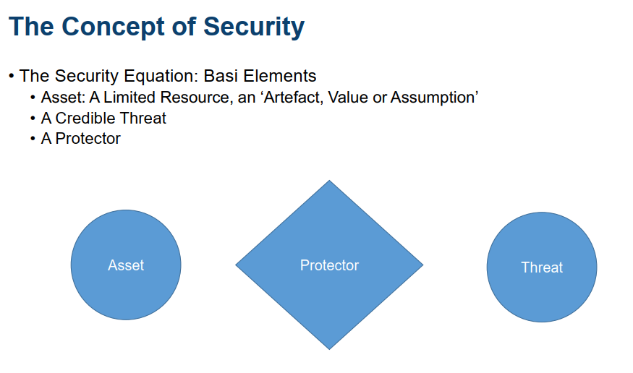

* **Security ~ Interconnected world:** 
  + Global security’s major challenge is to contend with the concept of security and the security complex.
    - **Concept of security:** Security concerns are deeply interconnected to the point that one state’s security needs cannot be realistically considered without taking into consideration the security needs of other states (Mcsweeny, 1999).
    - **Security complex:** Breeds rivalry among states. This causes minor and major competition. Remedy for such rivalry lies in cooperation. Solving the competition with peaceful terms. Logical process of reasoning, choices, actions. Depends on the interest of the state.
  + Rummel argues that since international relations lacks a central government with a monopoly of power states are insecure(1979, p. 45). In Hobbes terms this is “lack of common power yields a condition which is named as war” (Ratcliffe, 2018, p. 768). Their protection depends on themselves and what faith they can put in their allies. This insecurity will breed arms for defense. The reliance on self-help and the security dilemma creates a constant disposition to violence, a state of war.
* **War, as part of this competition:** War is inevitable part of this competition.
* War does not belong in the realm of arts and sciences; rather it is part of man's social existence. (Clausewitz, War is an act of human intercourse, p.149)
  + I.Z: He sees war as social phenomena.
* War is a clash between major interests, which is resolved by bloodshed - that is the only way in which it differs from other conflicts. (Clausewitz, War is an act of human intercourse, p.149)
  + I.Z: It is that War is merely the continuation of politics by other means. p.87.
* War is a social activity between actors with a will of their own and with hostile feelings and intentions and emotions[p.76], the ‘collision of two living forces’[p.77] that are ‘opposed in equal measure to each other’.[p.83]
  + I.Z: Clausewitz defines war as clash of opposing mindsets. Process of this: He relates two wrestlers in a ring. Before ring they are preparing themselves which means organizational development. You cannot just walk to war, you have to develop the capability.
* War in itself has no logical limit to the application of force (p.77).
  + I.Z: War has a tendency to premordial violance, devoid of reason and purpose. It has tendency to escalate beyond any usefulness to policy. Ukraine war: violence that possibly doesn’t need to reach the extremes. That it seems to reach.
* Each side will compel ‘its opponent to follow suit; a reciprocal action that must lead, in theory, to extremes’[p.77] in use of force, exertion of strength and to rendering the enemy powerless.
  + I.Z: One of the purposes of policy limits this process with imposing self-limits. Do not use the ultimate force, nuclear weapons. Geneva conventions, international laws on war and humanitarian law created to regulate war not to go these limits.
* **Strategy: Principle notions and effects:** Contribute towards a lot of metrics.
* **Relationship between policy and strategy:** 
  + I.Z: Policy, intent, strategy, plans are all conceptual undertakings to put things on ground for action. There is nothing happening on ground.
  + Journey from production of policy to action we transition (go around outer circle of prism);
    - from aspiration to an intent,
    - from intent to action,
    - And action we must measure against the aspirations.

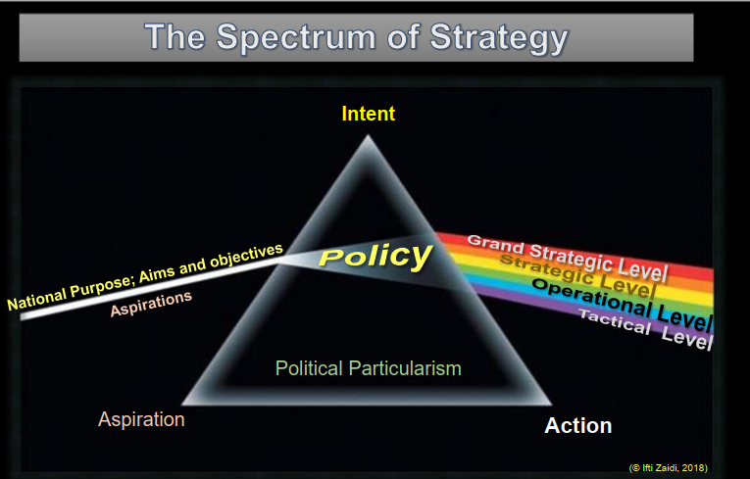

* + Where does aspiration comes from? How does it produce intent?
    - Aspiration-intent plane, anology of white light (public pulse, elective power) striking prism.
    - Abstract questions: What the public&people wants? What do the people that are aligned towards their common purpose that constitutes the nation state?
    - The purpose of the leadership&politicians is to translate this into policy. They do this in three steps:
      * Define national purpose, aims and objectives. They maybe not written. Just in heart. Embodied in collective rather than individual.
      * This pulse is what the politicians must work with. From this pulse they produce policy. That is converting aspirations into intent. And the first level of expression of intent is policy.
      * Who makes policy? Made by people. Turn up to Clausewitz, war is a social undertaking. You can take it to any policy. It is people who make choices. Inclinations, perceptions of others is important in how they process information. Decisions they arrive.
  + Labor and conservative parties: National purpose, aim and objectives are the same. They lead same people. Objective is maximizing the potentials of its citizens. Thats why governments exists for. Provide an environment for citizens to achieve their maximum potentialty.
  + **Political particularism:** Different policies, Conservatives policy may be different, prism is replaced, they view through all these by their prism, others with other prism.
  + As a result of particular prism being placed, dealing with the same national purpose, aim and objectives, the intent will alter, as a result of this intent, the emerging grand strategy, strategy, operational and tactics will also alter.
  + It is a political undertaking with a political outcome. Because it is political it is subject to change. As government change, the whole prism may be replaced. Personality in parties change, the focus changed. That will have an impact on the outcome out of prism.
  + Strategy is always subservient to policy. And must recognize that a limitation that it has to serve policy. And policy is not something that is fixed.
  + Policy can be defined generically as a course of principle of action adopted or proposed by an organization or individual.
  + Policy only works if there is a credible strategy to deliver it.
  + Strategy demands an achievable policy and state. Policy cannot ambitiously demand something of strategy that it cannot resource.
  + Strategy must have clear liberties within that policy framework iot be able to act and deliver.
  + Good policy should ordain the end and indicate the broad parameters of the means, but not necessarily the ways. So strategy, similarly, whet it translates into lower levels of action must in turn do the same.
  + So policy dominates the strategy by its articulation of the end state and and its guidance regarding resources, limitations on actions.
* Grand strategy: Intellectual architecture that gives form and structure to strategy, operations, and tactics.
  + Foreign and all contributing policies which, although pointing inwards, make the state competitive.
  + Political process: Grand strategy stems from a aspirations (light) that represents the sum of ideas, hopes, visions of the constituency. If this is not represented, there will be disconnect. Clausewitz’s idea of war as instrument of policy as one of trinity (The people, the military, and the government) (1984, 89) corresponds to grand strategy.
  + Political leaders not reacting events when they craft policy. They create meaning and understanding to enable grand strategy. A purposeful and coherent set of ideas about what nation seek to accomplish and how it should go about doing so.
  + Grand strategy require clear understanding of what is happening in the international environment. A countries highest goal and interest within the environment.It is a rational understaking. Balancing aspirations with means. Means in national level are national power, or elemnts of power. DIME~material + Cultural or social power~non-material. Culture is power denominator, soft power that provides impetus to government.
  + Hart defines grand strategy as “policy in execution” and its role as to coordinate and direct all the resources of a nation towards the attainment of the political object of the war (1991, 322).

Bibliography with abstract

Clausewitz, C.W., On War, Princeton University Press, 1984.

Hart, Liddle. Strategy, 2nd revised edition, First Meridian Printing, 1991.

McSweeny, Bill. Security, Identity and Interests, Cambridge University Press, 1999.

Makinda, Samuel M. 1998, Sovereignty and Global Security, Security Dialogue, Volume 29 Issue 3, page(s): 281-292, September 1998, SAGE Publications.

Manunta,G . (2002) Risk and security: Are they compatible concepts? Security Journal 15(2):43 –55.

Williams, Paul D. 1998, Security Studies: An Introduction, Edited by Paul D.Williams, Routledge, Taylor&Francis Group, 2008.

National Interests, National Power, Interstate Competition, Dr Gemma Collantes Celador, Guest Lecture

* National Interest
  + Definition
    - Thoughts: Aspirations for future, Goals and objectives, Aspirations and objectives above politics commonly agree among society
    - Includes what (like territorial integrity)?: Anything that threatens the survival or well-being is in it. It has to be related with the basic existence of the state. Something thriving or the prosperity of the states could be considerd in it. GCC: These things are omnipresent but poorly defined.
    - “Slippery concept” (Nye 1999: 22) – description and prescription in relation to the aspirations of sovereign entities in the international arena (Nuechterlein 1976: 246).
      * GCC: It prescribes what aspirations should be like how state wants to be and wants other to see it in 2025. It also describes what the aspirations is. Reality of how state understand it like sensitivity of territorial integrity. Should and is playing here. 1976-1999 not managed to solve yet.
    - “It carries an assumption that is it possible to define the national as a melding and cohering of all interests, including business, sectoral, regional, and religious, within a country.” (Deighton 2017: online source).
      * GCC: Melding together all other forms of it reflects the plurality of society. Is above politcs and relies on consensus. National interest also need to fulfill the needs of the society.
    - “It is a term deployed to allude to grand ideas and strategies and to conjure up an image of national power, rather than to illuminate what is actually going on in the foreign policy process, or routine political activity” (Deighton 2017: online source)
      * GCC: National interest is very closed with foreign policy but it goes beyond it through security policy. National interest is extremely important to conceptualize the concept of security.
    - GCC: There is no agreed definition but;
      * It has to be above politics and daily discussion (Deighton),
      * Supposed to be based on consensus, amalgamation of other forms of interest (Deighton)
      * Different level of discussion, value of topic is high.
      * Since there is no agreed def, it is sometimes abused, provide legitimacy to specific issues.
      * Different types of it (enduring, contexual etc) also contributes variety of definition.
    - “The national interest is the perceived needs and desires of one sovereign state in relation to other sovereign states comprising the external environment” (Nuechterlein 1976: 246).
      * GCC:
        + Nothing to do within the state.It makes sense to apply Nuec’s definition to Realist theory of IR where the focus is on how states interact with each other. Less attention to within the state.
        + Aspiration way is more close to think it domestically where interest comes from internal dynamics.
        + What factors feed into how states determine interest? Internal or external. And how they balance.
    - The national interest/s as entailing:
      * What a state aspires to become – for example, a developed country, a regional or global power, the promoter of ideological preferences and so forth.
      * What it needs to meet that aspiration – security, economic well-being, and so forth.
    - Interest as a psychological meaning: (Rummel, 1975, Chapter 20)
      * Attitude represents a disposition to manifest specific behavior regarding some goal and need.
      * Interest, then, is the **power of the attitude** based on a need.
        + Situation: is I am tired (Exhausted from studying)
        + My goal: to relax without mental effort
        + **Choosing activity** depends on the **power of my need** which turns out to be interest.

İnterest is low: no good programme on TV

Then read magazine.

* + - * An attitude, as the basic motivational unit, is a particular actualized potential with power to be manifest. The power of this potential is then the interest generated by a need. Power is the general term, and interest is its particularization in the motivation domain.
      * Interest is energy associated with the stimulation of a need, and an attitude is a force based on that energy and directed toward a particular behavior. Accordingly, attitude has the characteristics of another psychological vector.

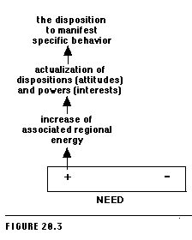

* + - Interest as a social implications: (Rummel, 1976, Chapter 19)
      * Intentions has three elements; interest, gratification, and will.
        + Interest is ***activated (energized) attitudes*** linked to a need.

Needs, the source of the psychological energy driving us to seek something like security or hunger, become attenuated through a variety of wants and gratified through a variety of goals.

Attitude is a want of the form "In this situation I want to do this with that." The attitude combines perception ("In this situation"); the self ("I"), the desire, wish, or craving ("want"); the goal ("to do this"); and the object of the goal ("with that"). The attitude thus gives specific direction to our needs. 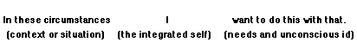

* + - Forces of international relations generated by interests. And its dynamics comprise the conflict helix. (Rummel, 1979, p.55)
  + Rationality vs morality:
    - “Pursuing the national interest is, for any government, a practically unavoidable goal, and that adopting ends incompatible with it is, therefore, irrational” (Oppenheim 1987: 369).
    - “In a democracy, the national interest is simply the set of shared priorities regarding relations with the rest of the world. It is broader than strategic interests, though they are part of it. It can include values such as human rights and democracy, if the public feels that those values are so important to its identity that it is willing to pay a price to promote them […] A democratic definition of the national interest does not accept the distinction between a morality-based and an interest-based foreign policy. Moral values are simply intangible interests. Leaders and experts may point out the costs of indulging these values. But if an informed public disagrees, experts cannot deny the legitimacy of public opinion. Polls show that the American people are neither isolationist nor eager to serve as the world’s police. But finding a middle course is proving difficult and complex” (Nye 1999: 23-24)
      * GCC:
        + Definition is made after US intervention in Kosovo while trying to define what is US interest.
        + If public feels.. Inward looking. Public expectations feed into notion of national interest.
        + Alludes to public and national identity. Implicitly engaging the notion of national identity.
        + Nye implicitly emphasizes increasing connection between core values of states and societies with the definition of security. In this view security is conceptualized as protection of core values that embedded in identities.
        + Moral or interest based foreign policy:

This differantiation depends on the context.

Oppenheim’s definition is made during cold war, where countries cannot afford to take decisions on a morality based. Because rational choice requires any action should be fulfilling the national interest and needs of state. Therefore there is no role for morality.

Inward (protection of core values) or outward (it might be national interest to adhere the rules of UN which are morality based) looking.

It is difficult to disaggregate those.

* + - GCC:
      * The context and evolution in our thinking is very important to decide rational or moral view. National interest in Cold War era will be different today. Different variables operate in different context.
      * Complex questions to be asked about morality and rationality embedded in the national interest.
      * Delicate balance to bringing forward both rationality and morality in exercising national interest.
    - Gordon Browns Global Ethic vs. National Interest Speech at TED
      * He is calling for global ethic. It is about global citizenship and recognizing responsibilities to others. It is obvious to build a better world to better met the challenges. It will make people talk each other across continents. That requires to create institutions that make that global society work. Massive changes of technology make possible to link the people accross the world. How to combine patriotism with it? National identity remains important. But it is not at the expense of people accepting their global responsibilites.
        + Recession is caused by people become more protectionist. Looking inward at the expense of other nations. Motor of world economy canno move forward unless there is trade between nations. Any problem can be solved by nation.
        + Public persuation on long term interest of state is proper engagement with the world.
        + It is enlightened self-interest for us to work with other countries. National and global interest come together in the long run in tackling the poverty and climate change.
    - GCC: National interest based on Rational choice or values, ethics which pushes us beyond our comfort zone.
      * Overlap in core values of identity and protecting it is in national interest and the values at regional and international level. Complemetary
      * Difficult to maintain balance between them when implementing national interest. There are different things put together in an equilibrium.
* National Power
  + Definition
    - “The ability of a country to shape world politics in line with its interests” (Beckley, 2018: 7)
      * GCC: Power is the ability to influence the behaviour of others so they would behave in the way that you want them to behave.
      * This is basic definition. To into deeper we may look it from security perspective.
    - Hans Morgenthau – power for different purposes, with different meanings. “Power is always both that which explains and that which is explained”.
      * GCC: Morgenthau is one of classical realist. Father of security thinking. Key thinker of notion of power.
      * Power is explained ~ object of explanation, Power explains ~ What we use to explain something.
      * Multifaceted aspect to power. It is *mean* to fulfill national interest but it is also *end* as object of national interest like gain more power.
    - Guzzini argues there are three understanding of power under classical realist thought.
      * Political Theory or ontology – “a trait of human nature, constant throughout time, the *animus dominandi*, that is, the potentially insatiable will for power over others”
        + GCC: State behaviour in this case would be pursuance of more power. That would be the end.
      * Explanatory Theory (GCC: when applied to power)
        + Interest maximisation
        + Definition of national interest in terms of power. GCC: Or how can power enable fulfillment of national interest.
        + Power as a relation (the importance of reputation) but also as that which causally affects a relation. Power as cause and influence. GCC: Tangible like economic, military.
        + 3 forms of action: maintaining, expanding, demonstrating power.
      * Foreign Policy Strategy – behavioural ideal – still related to the national interest. (Guzzini 2018: 29-30)
        + GCC: Power is a capacity of a nation to shape the behaviour of others.
    - The purposes of his power threefold. Guzzini 2014: 5
      * First, power serves to define the specific logic of politics in the social world, hereby providing the ontological anchoring of Morgenthau’s approach.
      * Second, power is the second explanatory factor in a utillitarian theory where states seek either the preservation, expansion or demonstration of power.
        + GSS: States may try to preserve the status quo. Expansion, revision of current system to accumulate more power. Demonstration of power: stop others taking power away.
      * Finally, Morgenthau looks for an ethical usage of power in a foreign policy strategy, a praxeology of the lesser evil.
      * Although his own way of tying this package of ontological, explanatory and practical-normative purposes may be unique, those purposes are intrinsically connected to the reasons for which we use the concept of power – even though many of those purposes and meanings will be temporarily lost during the next decades of IR.
    - Power is the capability to produce effects. Rummel 1976: chapter 26, Social power is an intentionally directed capability to produce effects through another person. Rummel 1976: chapter 27. Social power has six forms: coercive, bargaining, intellectual, authoritative, altruistic, and manipulative. Rummel 1977: chapter 2
    - Rummel argues that reality comprises potentialities, dispositions, and power. What aspect become manifest depends on confrontation between reality and perspective[1]. What we perceive is the result of the conflict between this vector and reality’s inward bearing vector of power. So conflict is a balancing of vectors of powers to produce effects (Rummel, 1976, Chapter 26).
  + Sources
    - Power draws from the following:
      * Territory
      * Population
      * Political stability
      * Economy
      * Military
      * Anything else? GCC: Culture
    - Instruments of National Power: **DIME**
      * **D**IPLOMATIC – Persuasion, Reputation, Communication, Integrity, Ability to use force = ‘coercive diplomacy’.
        + Embasies&ambassadors, Recognition, Negotiations, Treaties, Policies, International forums.
      * **I**NFORMATIONAL/INTELLIGENCE – instrument in its own right (increasingly) but also informs, influences, underpins the application of other instruments of national power.
        + Military information, public diplomacy, public affairs, communication resources, international forums, spokepersons, timing, media and venues for announcements.
        + GCC: Some sees that as independent instrument, some other see as an instrument that feeds into the other. Need for information& intelligence for diplomatic, military or economic. So this may be seen as integrated into ability of using other instruments.
      * **M**ILITARY – Defence, Offense, Deter, Coerce
        + Military operations, engagement, security cooperation, deterrence, show of force, military technology, size, composition of force.
      * **E**CONOMIC – Influence decisions and affect behaviour
        + Trade policies, fiscal and monetary policies, embargoes, tariffs, assistance.
    - How do we measure ‘national power? Resources vs. Outcomes (Beckley 2018)
      * GCC: When instrument puts into practice how it measured?
      * Number of methods depend on how national power defined.
      * Much easier to measure in terms of resources (DIME) than realizing the outcome.
    - How these instruments of power put into practice?
      * GCC: One example is Fusion Doctrine, UK National Security Capability Review, 2018. This is how UK conceptualizes of its instruments of national power and where the sources of these instrumets are and how they can be brought together to reach national objectives.

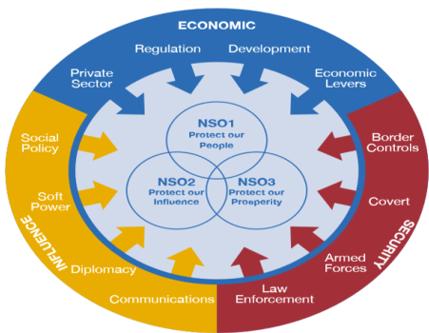

* + - * Information power is embedded practically in influence.
      * Mention of soft power. It is not explicitly mentioned in DIME but increasinly playing role. It is basically cultural instruments that contributes to national power.
      * DIME should be expanded to include social&cultural power. Good example of it is 2021 Integrated review of UK. (UK Integrated Review of Security, Defence, Development and Foreign Policy, 2021). In a way we talk about instruments of national power indirectly, we then engage in cultural factors. We need to be careful about this. We’re talking about values represented&upheld and behaviours that associated by state. And how states may be able to use those as new forms of influence others and therefore becomes power. That influence on the basis of prestige, reputation, and integrity so on and so forth. These are not perse the culture, I think we need to move away. It is very different use of the notion of culture. Here is more about values that adhere to and they practice it their behaviour at home and beyond. Integrated review is reflecting that.

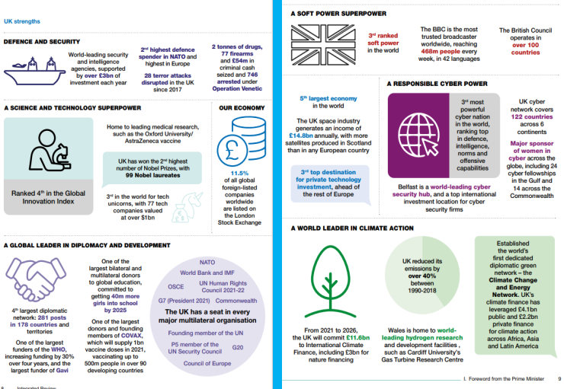

* + - * In this image there is diplomatic, military, economic, information – through cyber powers.
    - GCC: The way we define instruments of power needed to be expanded what is happening in real life especially sof power. That brings us to the notion of Hard&Soft Power
    - DIME is forms of what?
      * GCC: Peacekeeping operations. Use of military for peacekeeping operations fed its diplomatic efforts. It is also form of soft power. Behaviour and image that they convey on the populations is a form of soft power. More space needed to social dimension of values. This is another form of national power.
    - Hierarchy of action in instruments of power (DIME)
      * GCC: This is important for policy development. Reality is a little bit messy. It depends how you understand the threat or challenge. Based on that what is the right combination of instruments of power. A couple of instruments of power maybe exercised simultenaously to maximize the influence.
      * Implicit understanding of hierarchy of action. Threats are disturbing interational peace and security that require response. Chapter 6 of UN Charter, first solve the problem with negotiation, diplomatic means (article 33). Here informational &intelligence power important. If it doesnt work you move to chapter 7, increasing levels of coercion or hard power culminating on military (article 41, 42, 51).
* Interstate Competition
  + GCC: Depends on the level of analysis
    - From IR theories perspective: In realist understanding of security states by default compete. Being state is about accumulating power to better protect themselves. Where they cooperate is a form of attentuating and controlling the dynamics of competition.
    - Level of structure: States could be cooperating within a region but regions may be competing each other.
  + Rand corporation Understanding the Emerging Era of International Competition Report
    - GCC: Rand corporation report mainly deals with how USA should think about interest, interstate competition against the background of increasing allusion to how we enter new period of interstate competition, very much driven by power less so by rules. USA National Security Strategy reflects this.
    - What do we mean by the concept of ‘competition’ when applied to interstate relations?
    - To answer that we need to distiguish what is the difference in meaning between these concepts?
      * Competition
      * Conflict
      * Rivalry
      * Contestation
      * Cooperation
        + GCC: Not the same. There is nuanced differences. Different stages between states.
    - “Competition in the international realm involves the attempt to gain advantage, often relative to others believed to pose a challenge or threat, through the self-interested pursuit of contested goods such as power, security, wealth, influence, and status.” (Mazarr et. al. 2018: 5)
    - Assumption is, this is the nature of competition.
      * “First, competition always involves some degree of antagonism & contention, but the specific degree - the intensity of antagonism and hostility in competition—can vary significantly. Two parties who are mutual partners and who share common goals and interests cannot be said to be competing. In this sense,
      * Second, competition is generally viewed as a contest in which each party (or one of the two parties) aims to enhance its power and influence, typically relative to one another.
      * Third, while not all competitive situations are zero-sum or focused on relative gains, generally the term refers to a situation in which there is either (1) scarcity in the object of the competition or (2) significance to getting more of that object than someone else. If three or more countries are interested in something that is widely available - and possessing it conveys no special advantage - the resulting pursuit of gains might not rise to the level of a competition” (Mazarr et. al. 2018: 3-4)
    - Nature vs Character of competition:

1. What is the essential character or nature of the competing nations?

Type of regime, type of leadership, ambitions and grievances, national identity, etc.

1. What do the participants compete for (what are their goals)?

Security, status/standing/prestige, material economic prosperity/power, territorial/sovereignty claims, values and ideologies, rules/norms/institutions of the regional/international system, etc.)

If competing for power, how much power is enough power?

1. How do they compete (what strategies or capabilities do they employ)?

What instruments of national power they utilize to engage in competition.

1. What specific international systemic patterns or structures come to

characterize the competition?

1. To what degree does the competition reflect factors that theory and history suggest determine its intensity? (the material in this slide comes from Mazarr et. al. 2018: 13)

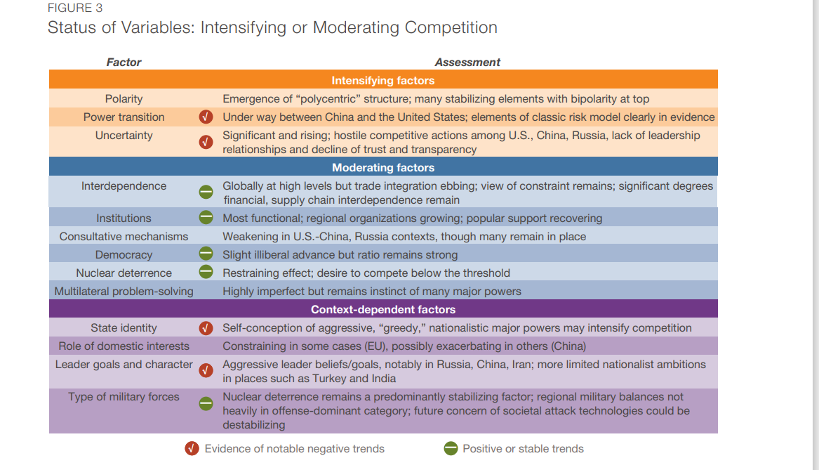

They tried to map global competition.

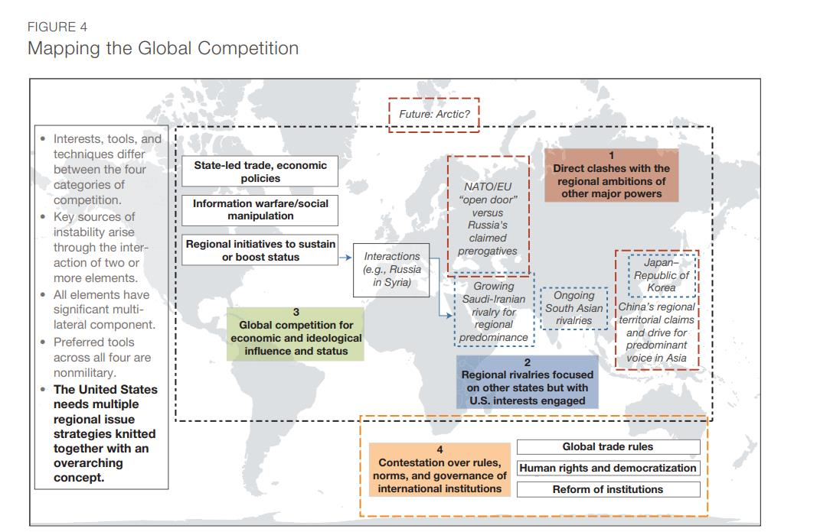

* Main conclusion: If definition lacks, working definition provides base for further discussion.

Beckley, M. 2018, “The Power of Nations: Measuring What Matters”, International Security, vol. 43, no. 2, pp. 7-44.

Brown, Gordon. 2009, Global ethic vs. national interest, TEDGlobal 2009.

Deighton, Anne. 2017, “National Interest” – What do we mean?, https://blog.politics.ox.ac.uk/national-interest-mean/

Guzzini, S. 2018, Hans J. Morgenthau and the Three Purposes of Power, DIIS Working Paper no. 4, 2 November - https://www.diis.dk/node/21415

Mazarr, M.J. et. al. 2018, Understanding the Emerging Era of International Competition Theoretical and Historical Perspectives, Research report, RAND Corporation – https://www.rand.org/pubs/research_reports/RR2726.html

Nye, J. 1999, “Redefining the National Interest”, Foreign Affairs, vol. 78, no. 4, pp. 22-35.

Nuechterlein, D.E. 1976, “National interests and foreign policy: A conceptual framework for analysis and decision-making”, British Journal of International Studies, vol. 2, pp. 246-266.

Oppenheim, F.E. 1987, “National Interest, Rationality, and Morality”, Political Theory, vol. 15, no. 3, pp. 369-389.

Rummel, R.J., Understanding Conflict and War, Vol. 1, The Dynamic Psychological Field, Beverly Hills, California, Sage Publications, 1975.

Rummel, R.J. Understanding Conflict and War, Vol. 2, Tthe Conflict Helix, Beverly Hills, California, Sage Publications, 1976.

Rummel, R.J. “Understanding Conflict and War, Vol.4: War, Power, Peace, Beverly Hills, California, Sage Publications, 1979.

UK HM Government 2018, National Security Capability Review –https://www.gov.uk/government/publications/national-security-capability-reviewnscr

UK HM Government 2021, Integrated Review of Security, Defence, Development and Foreign Policy - https://www.gov.uk/government/publications/global-britainin-a-competitive-age-the-integrated-review-of-security-defence-developmentand-foreign-policy

UK HM Government 2015, National Security Strategy and Strategic Defence and Security Review - https://www.gov.uk/government/publications/national-securitystrategy-and-strategic-defence-and-security-review-2015

United Nations Charter, 1945 - https://www.un.org/en/about-us/un-charter

* Introduction to policy development and analysis
  + GSS: Connection between policy - long term statement of objective - has to be aligned with overall objective of a state (interest). These objectives naturally constrained by power and competition. Explicit wording has implicit implications under.

Source: Fitz-Gerald, Ann.

* + Possible Definitions:

1. Policy is about providing the *strategic vision* for states and their governing institutions.
2. Policy is “the result of efforts made by governments to alter aspects of behaviour—both that of their own agents and of society at large—in order to carry out some end or purpose”. (Howlett & Murherjee, 2014, p. 57)
3. Policy is about “systematically match[ing] ends and means in the attainment of public policy goals” (Howlett & Murherjee, 2014, p. 65)
   * Policy and Strategy relationship
     + What **ends** (i.e. objectives) do we wish to achieve?~ Policy
     + What **constraints** should be applied to our actions? ~ Policy
     + What **means** (resources) do we have at our disposal to achieve our ends? ~ Strategy
     + The available **ways** (i.e. courses of action) to use our means to achieve our ends. ~Strategy
   * **Why do we need policy?**
     + A key purpose of all policy is **to give guidance** so that:
       - multiple actors behave in a **coherent way**;
       - domestic and international audiences are informed about a government’s intentions and plans – transmitting reassurance and determination.
       - A government may wish **support** for policy:

from service personnel

from taxpayers

from the widest public

Form regional and international allies

There may be legal requirements – e.g. Freedom of Information legislation, media policies, treaty obligations, etc.

* + - In addition to ‘guidance’, policy provides us with a base line against which to:
      * **Measure progress** (or lack of it), and
      * Hold those responsible for implementation **to account.**
      * The importance of determining how success and failure looks like.
    - Policy should therefore indicate the following:
      * Where are we now? The Strategic Context
      * Where do we want to go? The National Interest, Security Objectives
      * How do we get there? **The relationship between Policy and Strategy**
  + **Policy Development**
    - Stages heuristic model of public policy-making (Harold Lasswell, 1950s)
      * GCC: Advantages: Simple and methodological.
      * Disadvantages:
        + Policy is messy, doesn’t follow step by step. Back movements happen. You may do legitimation in agenda setting, policy manifestos of political parties in election, the way these political manifestos are developed, if they are already in, they are already catering to that aspect of legitimazation.
        + It doesn’t tell how long it takes from one step to another. Depending on state, structure it might take little or long time between steps.
    - **Norris, 2012:36 Model**

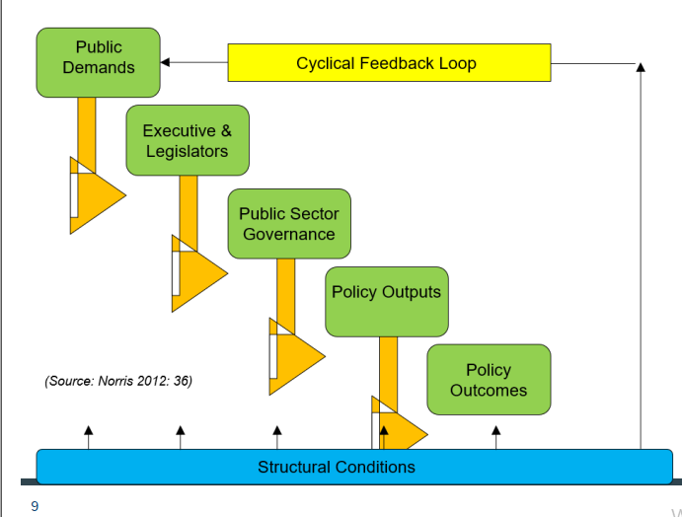

* + - **DCAF, 2015:5**

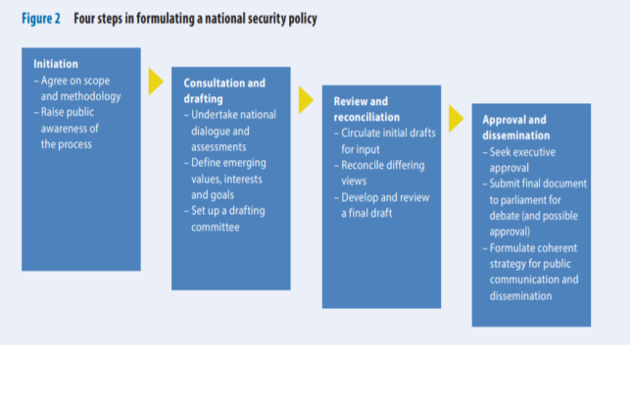

* + - Other model of public policy-making: **Multiple Streams Framework**, John Kingdon, 1970s-1980s
      * “Three categories of independent (and interdependent) variables that interact to produce ‘windows of opportunity’ for agenda setting” (cited in Bewland & Howlett 2016: 222)
        + Problem Stream
        + Policy Stream
        + Politics Stream
    - Other model of public policy-making- **Punctuated Equilibrium,** Frank Baumgartner & Bryan Jones
      * Reaction to Incremental Theory (Charles Lindblom)
      * “Linear and incremental changes over the long-term did not explain policy-making. (Amri & Drummond 2021: 35)
      * Periods of incrementalism in government action and decision-making are accompanied by “punctuated” periods of volatile, high-profile, dramatic change.
      * Policy sub-systems
      * Moments of punctuation caused by external or internal factors? GCC:Depends of nature of event. Ukraine war is external, 2008 economic crises is internal.
  + **Who has to be involved?**
    - “The government and its advisers creates and seeks to implement policy. The legislature may agree or decline to fund it, or to pass the laws necessary for its implementation, while the judiciary may, under some circumstances, place legal limits on what can be done. Other non-elected groups, with varying degrees of legitimacy, may try to influence or obstruct security policies” (Chuter 2011: 9)
      * GCC: It goes beyond to private sector, regional and international level influences. So list may include:
        + Party, cabinet
        + Subject matter experts
        + Institutions~ by law or custom involved
        + Allies, donors, international organisations
        + Lobbies&pressure groups
        + Think-tanks
        + Those affected by the policy
  + **How important is the context?**
    - The nature of policy formation is dependent upon the constitutional framework and the powers vested in certain institutions and individuals – the structure of government.
    - Policy should be nested within a supporting policy framework with a clear understanding not only of who makes policy but also who implements it and how.
    - The example of National Security Councils
  + **Top-down vs bottom-up approaches:**
    - A system that makes a clear division between policy decided by the minister and his advisors, and execution decided by officials
    - A system where officials assist with the formulation of policy and carry it out --->The role of civil service systems
  + **HOW DO WE IMPLEMENT POLICY?**
    - **Consistent objectives, achievable goals** – morale, motivation, credibility.
    - Policies should identify **factors that influence policy outcomes**
    - **Good structures** – supportive roles, procedures, resources.
    - Choosing **capable and appropriate actors**
    - **Information sharing and effective consultation**
    - The need to consider **how policy is reviewed**: Parliament, Auditor General, external bodies, international organisations, NGOs, media.
  + **HOW DO WE REVIEW POLICY?**
    - **“Monitoring** is the systematic process of collecting, analyzing and using information to track a programme’s progress toward reaching its objectives and to guide management decisions. Monitoring usually focuses on processes, such as when and where activities occur, who delivers them and how many people or entities they reach.” (UN Women)
    - “Monitoring is conducted after a programme has begun and continues throughout the programme implementation period. Monitoring is sometimes referred to as process, performance or formative evaluation”. (Gage and Dunn, 2009)
      * GCC: Heuristic model: policy evaluation is at the end. Monitoring would maximize its effect to ensure that the process is efficient and attains objectives for which it has been initiated.
    - **“Evaluation** is the systematic assessment of an activity, project, programme, strategy, policy, topic, theme, sector, operational area or institution’s performance. Evaluation focuses on expected and achieved accomplishments, examining the results chain (inputs, activities, outputs, outcomes and impacts), processes, contextual factors and causality, in order to understand achievements or the lack of achievements. **Evaluation aims at determining the relevance, impact, effectiveness, efficiency and sustainability of interventions and the contributions of the intervention to the results achieved”** (Gage and Dunn 2007)
    - “An evaluation should provide evidence-based information that is credible, reliable and useful. The findings, recommendations and lessons of an evaluation should be used **to inform the future decision-making processes.”** (UN Women)
  + **OECD DAC Evaluation Criteria**
  + 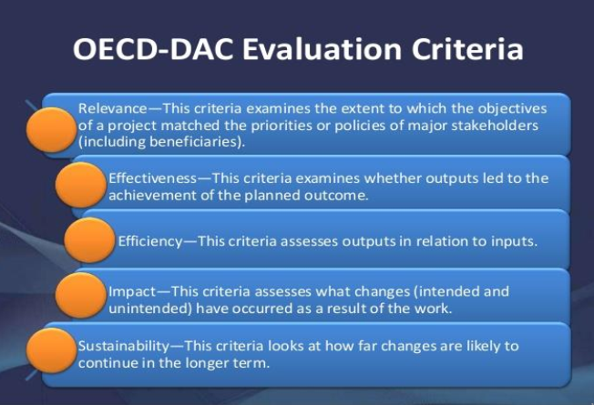

NATIONAL SECURITY POLICY

“The political direction of a nation’s security resources as a whole with a view to ensuring national security, protecting vital interests and furthering the international aims of the state”. (Chuter 2011)

“A national security policy is an official description of how a state aims to provide for its own security and that of its population […] It is intended to provide an overarching national vision as the basis for the development of other documents such as a national security strategy or subsector plans […] A national security policy is a guide to action for the government: it is not a law but its implementation may require changes in the legal framework that governs security provision, management and oversight” (DCAF, 2015: 2)

**Typical elements in national security policy, DCAF 2015:3**

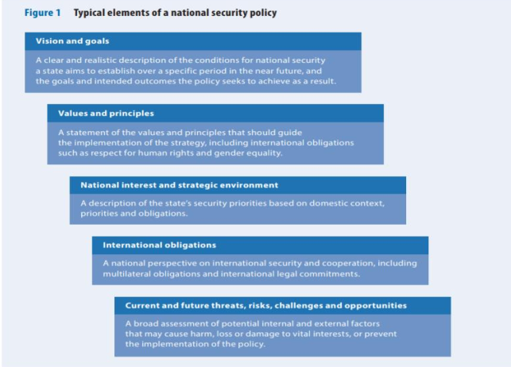

- Security policy addresses top level questions and issues:

• What do we want our security forces, ministries and agencies to do?

• How much do we want to spend?

• What are the parameters on how they can act/prepare?

- The role and purpose of top level security policy is to answer these (difficult) questions in a way that will give guidance to civilian officials and security officers who are charged with preparing relevant strategies.

The civilian officials and security officers who are charged with building the capability can then propose in subsequent stages :

• What are the tasks of different security actors?

• What kind of force structure is needed?

• What kind of equipment is needed?

• What other resources are needed?

• What kind of doctrine is to be written?

• What kind of people are to be recruited?

• What levels of preparedness and sustainability?

• In other words, all the elements needed to produce a coherent security capability

Example UK

2010

• A Strong Britain in an Age of Uncertainty - The National Security Strategy

• Securing Britain in an Uncertain World - The Strategic Defence and Security Review 2015

• National Security Strategy and Strategic Defence and Security Review – A Secure and Prosperous United Kingdom

2018

• National Security Capability Review

2021

• Global Britain in a Competitive Age - The Integrated Review of Security, Defence, Development and Foreign Policy

CONCLUDING REMARKS

Challenges to think about:

• When is policy needed?

• Balancing openness and secrecy in national security policymaking

• Costs and benefits of the review process

• Public debate vs expert inputs

• The relationship between formulation and implementation

• The role of political will and coordinated responses by/of stakeholders

Amri, M. & Drummond, D. 2021, “Punctuating the equilibrium: an application of policy theory to COVID-19”, Policy Design and Practice, vol. 4, no. 1, pp. 33-43 - https://www.tandfonline.com/doi/full/10.1080/25741292.2020.1841397

Beland, D. and Howlett, M. 2016, “The Role and Impact of the Multiple-Streams Approach in Comparative Policy Analysis”, Journal of Comparative Policy Analysis, vol. 18, no. 3, pp. 221–227 https://www.tandfonline.com/doi/full/10.1080/13876988.2016.1174410

Chuter, D. 2011, Governing and Managing the Defence Sector, Institute for Security Studies publication, South Africa - <https://issat.dcaf.ch/Learn/ResourceLibrary/Policy-and-Research-Papers/Governing-Managing-the-Defence-Sector>

DCAF 2015, National Security Policies, SSR Backgrounder – <https://www.dcaf.ch/sites/default/files/publications/documents/DCAF_BG_9_National%20Security%20Policies.11.15.pdf>

Howlett, M. & Mukherjee, I. (2014), “Policy Design and Non-Design: Towards a Spectrum of Policy Formulation Types”, Politics and Governance, vol. 2, issue 2, pp. 57-71 - <https://www.cogitatiopress.com/politicsandgovernance/article/view/149>

INTRODUCTION TO FOREIGN POLICY DECISION MAKING AND STRATEGIC DECISION MAKING MODELS, DR KRISTINE ZAIDI

Research area: Links between foreign policy and decision making.

* **DM as a sub-concept**
  + **Power of DM from classics to modern days**
  + Classical thought - the faculty and right to the decision associated with personalities/heroic leader (Centred on Agency)
    - KZ: Evidence from Aristotle’s ethics and DM and later Machiavelli. There were variations reflected political regimes of the time. Ex, Greek classical thinking was moderated to some extent in the classical Roman model, where democracy, aristocracy, and monarchy refused. Emphasis on the leader further manifested in absolute monarchies through the role of emperors. Chosen ones with some element of divine power. As such, they are centered in what we nowadays understand with the notion of agency. In philosophy agency is defined as a capacity of an act in a given environment. In this environment related to the social structures. So what extent a leader can act is defined by the social structures they operate in. They can work within the social structures. They can ignore or modify social structures. That’s a kind of balance between structures and agency. Ability to act is very personal to a particular individual based on their values. Notion of agency is directly related to the way individuals make their decisions. Classical thought and DM is very much focued on that individual and the ability to take decisions.
  + Hobbes’ power of a sovereign / Locke’s ideal of a limited government / Rousseau’s political leaders as agents of people / Weber’s elite administration (Transition to Structuralism)
    - KZ: In the 17 th century start to see the gradual evolution of the notion of individuals and sovereign. Hobbes attributes power to soveereign. He talks about diversity of opinions both political and religious. However he attributes the right to sensible to the sovereign. Sovereign right to decide across the realms, including notions such as just and unjust. Still very much focus on agencies but need to moderate because of different opinions.
    - Locke, several decades later provides different idea of sovereignty, putting sovereign power within mojority & civil society. He proposes limiting the role of government as in classical liberalism. Locke is often referred to father of liberalism. All members of society have equal right to participate and limit government and also possess negative freedom from expressive government. Freedom from interference by government.
    - Rousseau, 18th century, political leaders as agents of people rather than independent DMs. Aspirational model that suggest limited agency of DMs and ambiguity of structures. So moving away from that centrality of agents on DM into being the agent of people’s decision maker. Being agent of people. These ideas enable broader political participation and electoral representation underpinning the idea of direct democracy. Taking away that ability to act on its own right from agency and moving it closer to structures. Structures here are not just phsycal institutions, these are also rules, regulations, customs that underpin the process and relationships.
    - Max Weber, profound effect on bureaucracy, he took step forward and articulated the role of structures. so reflecting and public role in governance and decision making. He noted that an ideal participatory democracy is impractical in large and complex more than societies. So he proposed that governance must instead be in hands of an elite administration that cannot be directly accountable to the masses. I think we can see the impact of Weber's thinking on some of the structures of international organizations, like European Commission. Weber view the general public is irrational and ignorant and this perspective fueled his thinking on on the need for elite bureaucracy. He saw democracy as least rule of the people, but rather rule of an elite which combines exceptional leaders and bureaucratic experts. So while Weber emphasizes the role of elites, the agency is moderated by structures. So this elite centric approach contradicts the view taking by Kant who emphasizes the role individuals as rational and reasonable. Contradicts also concept of equal representation that developed in 19th century but fueled from earlier thinking of Locke and Russeau.
  + Shift of paradigm in 19/20th century – (More significant role of Structures emerges)
    - KZ: Shifting from individual agency towards a dominant role of formalized structures. This shift is most prominent in emergence of international organizations and the way western democracies operate from checks and balances through assigned and regulated roles of different branches in government. This evolution of domestic politics and international order occurred due to series of epochal events like WW1, WW2, and Cold War. In western democracies the overall impact was diminishing the role of agency. This evolution continues. We see the emergence of structural DM model such as rational actor and incrementalism.
  + Renewed emphasis on agency, evident in relatively recent literature. KZ: This comes from the critique of classical DM models. Classical DM models that do not pay due attention to human factor and look to DM as a sort of mechanical process, taking decisions through structures.
    - Decision making is an essential administrative process, but it is fundamentally a people process (Fred Lunenberg, 2010)
    - No crises or war can be understood without direct reference to the decision making of individual leaders (Renshon and Renshon, 2008) Kristine Zaidi (2021)
    - KZ: We need to understand what drives individual leaders, what motivates them. What informs the way they take certain decisions and certain contacts. A full circle is made started with center on agency, then went through evolution of structures, and again coming back to the emphasis on agency but operating within the structures.
* **Characteristics to Policy and DM**
  + Foreign policy is both product of, and input to decision making.
  + KZ: They are obviously closely related and supportive. They’re different yet inseperable. Policy, in its most refined form articulates objectives and decisions on how instruments of national power used to attain this. So, policy represents particular set of choices arrived through a specific political prism. And that in turn produces a framework within which future decisions are contained. Within this backdrop, I think foreign policy is input into and a product of DM and is in itself a decision or continuous series of decision.
  + DM in foreign policy is typically characterized by high stakes, ambiguity and uncertainty. And therefore then these decisions are not without substantial risks.
  + Decisions occurred in volatile, uncertain, complex and ambiguous (VUCA) environment (Barber, 1992; Bennis and Nanus, 1984).
  + KZ: Barber capitalize the term and applied to the policy environment. It was new either. He was inspired by early writings of Bennis and Nanus from business literature. It is an important concept because it defines the context in which decisions are made.
  + Clausewitzian analogy of the fog of war
  + Political and policy decisions are nearly always surrounded by cloud of uncertainty. It takes us back to Clausewitzian anology.
    - On War: Concept of the fog of war is introduced in intelligence section of On War as inaccuracy and inadequacy of intelligence. p.649. BERNARD BRODIE, A Guide to the Reading of On War.
    - On War: War is the realm of uncertainty; three quarters of the factors on which action in war is based are wrapped in a fog of greater or lesser uncertainty. A sensitive and discriminating judgment is called for; a skilled intelligence to scent out the truth.p.101, Book 1 Chapter 3: On Military Genius
  + So the ability to employ strategies that may help to improve the quality of decisions amid the uncertainties by choosing the best available alternatives becomes very important. Here we see the reference to rationality and DM. So there are alternatives, making choice based on the analysis of alternatives. This is the classical underpinning of the rational actor model.
  + Monopoly of government (small group within the government) in DM.
  + FP is expressed in its highest degree and perhaps only comparable with defence policy.
  + We can see it manifested very clearly in RAM.
  + Robert Putnam, 1988
  + He analyzes international negotiations through the prism of comparative politics and relations between domestic and international politics and says these can break down because of domestic frictions within the government.
  + Focusing on international objectives of the state is essentially misleading.
  + Participants attention primarily should focus on domestic objectives.
  + Knowing what are the domestic contacts, circumstances, battles, and the actors have to take on.
  + That impacts the decisions they make in international context.
  + Pressure of domestic groups at national level that government attemps to maximize at international level while minimising te adverse consequences of foreign developments. It is quite a balancing act that Putnam pays particular attention. Decision maker must be active on both side of the game and successfully mitigate both.
  + Suggest to look at the role of central executive, president or PM who has a unique role in mediating in domestic and international pressures. They are exposed to both.
  + KZ: But I think we can apply his concept much broader. Strengths of this model is domestic and international levels play the role of mutual enablers aiming to achieve a general equilibrium that accounts simultenaously for them. It is manifested when governments adopt policies they would not have pursuit in the absence of international engagements or negotiations due to the political constraints at the national level. It is manifested in how EU works. Some policies are adopted for example in environmental area that national government might not have adopted if there was no international pressure. National political structure is important to explain and predict FP actions.
  + DM is evolving field that includes multidisciplinary perspectives.
  + KZ: It needs to be seen through prisms of different disciplines (like classical thought and philosophy that shows how thought is evolved, or from the view of field of economics that RAM and Incremental Models derived of, or from the view of psychology and even neuroscience to understand the drivers behing individual leaders). It is inherently interdisciplinary field. It makes it more interesting.
  + Drawing from the existing literature on DM and public policy, most of which on domestic policy, much less on DM on FP. But we can deduct universal factors on which the science of DM hinges.
  + **Aims and Objectives:** What drives decisions. What decision makers trying to achieve and why? Objectives are short term or long term or combination of both?
  + **Context:** Plays paramout role. DM is always contextual with all complexities and uncertainties. FP DM operates in VUCA environment.
  + **Relationship between agency and structure**: Important for the analysis. Agency operates within the structures, amends & ignore or destroy the structures. Interplay between two is not static.
    - KZ: We saw it how it happened in Russia. We saw how structures were used to satisfy the ambitions of political leaders. For example in domestic politics we saw that how regional elections were abolished at some point. Then they were again introduced and then at and then again abolished, when President came to understand that some of the regional leaders gain more public support and more power with that. Elections were used for the domestic interest to reinforce the rule of President when it felt it could be undermined.
    - We could see it as swapping rows of the President and Prime Minister again İn Russian context when the Midwest of Cannon came into power as as a President Putin became Prime Minister and then and then they swapped again all through the elections of course all legitimized, but highly orchestrated as well.
    - Another example in terms of balance of role of agency and structures we saw during the Trump administration in the US. Under the Trump role of agency was evident and greater than the role of structures. Some structures particularly diminished like State Department. Decisions were very much around the leader. Although Biden has very strong opinions he operates within the structures. Structures are visible. Balance again shifted. Those things express themselves in democracy also.
  + **Choices, behaviours**
    - KZ:DM is people process and directly related to their position, abilities, interest, values, even their emotions. These are fueling their choices.
  + Cognitive abilities and constraints of individual decision makers
    - Human beings face these constraints by the virtue of human.
  + Possession and development of the **capability** to deliver on policy
    - It is good to have agency to have supporting structures, in some cases structures don’t interfere to pursue certain policies, but one needs to have capabilities to deliver so instruments of power that can drive the intent. Russia case, while there is long term objectives and aspirations, the ability to pursue those was not always present. Different reactions to events in Ukraine in 2004, in so-called Orange Revolution, change of regime, there is incremental decisions in Russia like increase the gas prices. But nothing near the decisions in 2014 the same protests but taking over Crimea. Capability to pursue was a long standing interest.
  + Analytical challenges on DM
  + KZ: Looking those are relevant for emprical analysis and theoretical framework, particularly when trying to develop our own framework for analysis. VUCA environment, vast amount of information&emprical data are examples of challenges. This complexitiy can be deducted to four major structural categories to help guide their analysis (just an example, conceptual framework may differ). Otherwise everything seems to be relevant. It enables to spot what is useful and what might not be applicable in any case. **Categories derived from theoretical models:**
  + **The Decision itself** — opens next three stages & indicators that can be systematically used in individual case study analysis. (**what?**)
  + Aim and objectives (**why** certain decisions are made?)
    - Setting aims and objectives
    - Anticipated changes
    - The role of context
  + Actors (**who**?)
    - Actors and decision ‘owner’. Including the level of delegation and devolution
    - The role of agency
  + Application of means (**how** they are implemented?)
    - What means are applied to achieve desired results, including time allocated to consider alternatives as part of decision-making process
* **DM Models:** KZ: Decisions on FP are analyzed according to these models.
* **Structured Models**: Comes from western structuralist approach which is their main constraints. Some degree they ignore the role of agencies and context.
  + Summary of Allison’s three models of foreign policy through which ***behaviour*** is seen: (Rummel, 1979, p. 65)
    - as largely purposive value maximizing ***choices*** of unified national governments (a rational policy model);
    - as routine ***outputs*** of large governmental organizations with their own goals, programs, and repertoires (an organizational process model);
    - and as ***outcomes*** of political bargaining and conflicts between bureaucratic groups and individuals within government (bureaucratic politics model).
* **Graham Allison and Philip Zelikow’s Rational Actor Model:** 
  + KZ: RAM is presented in 1969. Alison is economist and his emphasis is on payoff (karşılık). Salient feature: Explain the international events by recounting (sayıp dökmek) the aims and the calculations of national governments. Assumes that human behaviour is goal directed activity that becomes rational through;
    - Consistency in goals and objectives relative to particular action, and
    - Selection of **optimal option** that maximizes the output for a given input.
  + RAM is an expression of Weatern structuralism thought that follows prescribed process of arriving to decision. It is an idealistic approach to DM assumes that the human being is rational actor.
  + KZ:RAM emphasizes;
    - Structure over agency.
    - Role of a leader (power is highly concentrated), but leader operates within the structure and procedures.
  + KZ: RAM is Calculus approach to DM and premises on purposefulness in everyday decisions. Rationality imposes a consistent value maximizing choice within specified constraints.
  + KZ: Assumes rigid methodology on DM that requires preset steps to be taken to arrive a rational choice.
  + **Processof decision problem (from chart)** 
    - Interests, values, and objective are translated into a **payoff** (utility, preference) **function.**  This represents desirability of alternative consequences.
    - All possible consequences of action is ranked in order of impact.
    - The rational actor (decision maker) chooses among a set of other **alternatives.** These COAs provide distinct advantages and disadvantages, each indicating alternative policy choices with multiple layers of calculations translating interests into operational objectives
    - To each alternative is attached a set of **consequences** or outcomes should that choice become policy. Consideration of potential consequences includes an assumption about how accurately the decision-maker estimates the chain of events that follow from each potential course of action.
    - Rational **choice** simply consists of selecting the alternative whose consequences rank highest in the decision maker’s **payoff function.**
  + KZ: Quite simple and linear model DM. Step by step to achieve objective. While simple it includes complex process that relies a lot on cognitive ability of decision maker which is the point of critique.
  + KZ: Reality & VUCA environement is not that linear. Critiques mainly come from incremental model. Lack of human factor, presents DM as mechanical process I would argue it does not exist in real in its ideal form.

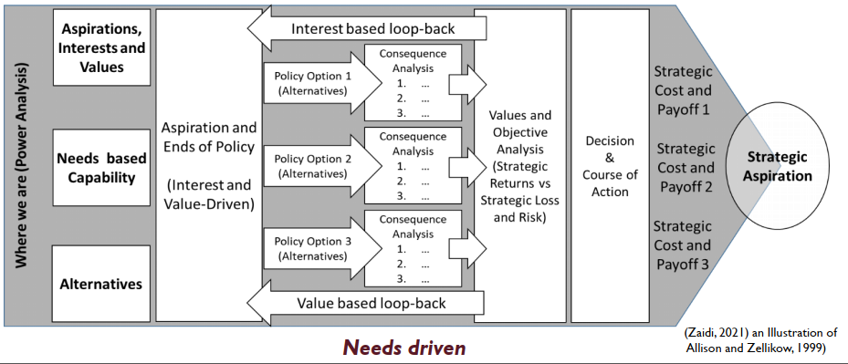

* + NATO: because there are so many interests at stake which are driven by people. People become their agency and within international organizations that some will have more agency than others. So balance has to be taken account. Useful tool as systematic and logical tool, but in political level it is much harder. It can be used as an input to political level discussions. Maybe rationality will continue because there are different interest at stake.
  + What are the alternative options for the Russia from the prism of RAM to maximize values and arrive to desired outcome?
    - Limited action, invade donbass, may deliver asp,
    - Diplomacy, cannot give its asp,
    - Project power, may deliver asp,
    - Sustaining foreign influence, cost&payoff analysis,
    - KZ: For its long term objectives Russia agrees to pay some short and middle term costs
  + **Critique of RAM:** 
    - **Simon’s critique of RAM**: He proposes notion of bounded rationality that explains cognitive and time limitation of DMs to consider all possible alternatives and consequences (Simon, 1972) especially in VUCA environment. KZ: Simon is still operated within rationality that was proposed by Alison. That’s why Simon’s approach is not a new model itself. It is a kind of subset. Alison and Zelikov came up with rational DM process they call it concepts.
    - Rigidity due to focus on end-goals of the decision maker.
    - Structuralist approach of model diminished the role of agency and human behaviour.
    - People are ‘predictably irrational’ (Janice Stein, 2012) Janice was neuropsychologist ~ people are a priori irrational actors (going through all alternatives and concequences is not human nature).
    - Agents have limits to their cognitive capacities (Robert Jarvis, 1976)
    - Perceptions and biases
    - Lack of awareness of cultural context.
    - KZ: Summary, structural model focuses on the process of arriving to decision making and largely **ignores agency and context** because it is very goal oriented activity. Anthony Dorn~if we know the end goal of decision makers we can predict their actions.
* **Allison’s two other models comes from critiques**. KZ: Allison review the critiques, did not review RAM, introduced two other models (generally overlooked). More pluralistic than RAM but inherently structural and procedural. RAM remains dominant model in analysing FPDM.
  + - * + **Allison’s Organisational Process Model,** mainly for Simon’s critique.

When the crises happen, governments (actor that holds everything in one hand) don’t look it as whole, but break it down and assign it according to preestablished organizational lines, so there is distinct roles and responsibilities within organisational lines.

Time and resource limitations force leaders to get satisfying solutions rather than an optimal solution as in RAM. Like Simon’s satisfying alternative. (emphasis on short-term solutions)

DMs usually follow the same well-established patterns (due to complexities and limited timelines)

* + - * + **Allison’s Bureaucratic Politics Models:** This particularly speaks to interplay between domestic and international DM**.** This came to critique of Samuel Huntington.And it's takes into account the court politics and palace politics. So there is that negotiation and bargaining that happens between individual leaders and government positions. And the leader itself needs to be taken into account this different interests.

Actions understood as bargain between individual leaders in government positions

Leaders must achieve a consensus that satisfies those players, court or cabinet.

So that the nation's actions are best understood as the result of politicking and negotiation by top leaders within the government. Even they share goals, leaders differ in how to achieve it because of such factors as personal interest and background.

Recognition of different levels of power based on personality, charisma, personal ties to decision makers

Emphasises the role of domestic politics

* **Charles Lindblom’s Incremental Model** SCIENCE OF MUDDLING THROUGH (towards a better future) (1959) KZ: He is economist and this model is influenced by free competition model of economics. He rejected the notion of centralization in DM (like the case in RAM) looking for collective good. Model is based on numerious actors, decision is the product of the agreement among themselves. He indirectly discussed the distributed nature of incremental DM. Very much interested in process of DM. Flexible than RAM. That model may shape strategy rather than being shaped by strategy. This is what Mintzberg describes as emergent strategy, as opposed to deliberate strategy. As an analytical model according to Lindblum, it makes the most of our limited abilities to understand the processes, so policy is not made once and for all, but it is made and remade endlessly through a succession of incremental changes or marginal differences in policies.
  + KZ: Influential article where he identified as a set of specific steps in the DM process that he called succesive limited comparisons or incremental. It presupposes that small steps in DM. This approach takes very different view on how decisions are made. It premises on the disparity between the requirements of the rational actor and their capacities for DM. Due to the complex nature of problems the decision makers are not amenable to total rationality. Decision makers must start from existing policy, and take remedial steps to cope with problems as they arise.
  + SCIENCE OF MUDDLING THROUGH (towards a better future). Hovewer future is uncertain, hence, long term plannig maybe useful, put secures no practical purpose.
  + DM is based on sequenced trials, errors, and revised trials. Examples: Response to COVID. Not incremental approach. Unknown situation government didn’t deal before. And there were elements of trials and errors, unfortunately with grave consequences. And then again revised trials. Incrementalism, analysis of emprical situation, Covid is good example to analyze it. My hypothesis would be incrementalism is good model to explain it.
  + There is no distinction made between the process of selecting value goals and empirical analysis of the need action, instead the two are closely intertwined. It positions DM of small steps in the right direction where **means and ends are not distinct.** End goal is not preset. So it is very different from RAM.
  + **There is no comprehensive analysis of alternatives** included; instead, the decisionmaker focuses on policies that differ incrementally from existing policies (simple incremental analysis). Analysis is, therefore, limited to a few familiar policy alternatives (Lindblom’s later addition).
  + Means-end analysis is often inappropriate or limited. **Only a restricted number of ‘important’ consequences are evaluated**. The problem is constantly redefined allowing for means-ends and ends-means adjustments, making it more manageable. Because changes happen very quickly no time for comprehensive analysis.
  + **The decision-maker takes small steps in the ‘right’ direction deciding whether the decision was right or wrong and altered as required** in particular time. As such, there is ongoing monitoring of each small step. Lindblom: *“incrementalism in politics is not, in principle, slow-moving… A fast-moving sequence of small changes can more speedily accomplish a drastic alteration of the status quo than can an only infrequent major policy change… incremental change patterns are… the fastest method of change available.”* Large changes through the steps. Safe option because errors can be rectified.
  + **There is no ‘right’ solution but a ‘never-ending series of attacks’ on the issues** at hand through serial analysis and evaluation. **Decision-making is based on a sequence of trials, errors, and revised trials.**
  + The analysis is drastically limited, and **only a relatively small number of policy alternatives are considered**, hence simplifying the character of the investigation. Consequently, important possible outcomes, alternatives potential policies and important affected values may stay neglected. Policy comparisons are limited to those policies that differ in relatively small degree from policies presently in effect.
  + Incremental decision-making is described as remedial, geared more to the alleviation of the present, concrete social imperfections than to the promotion of future social goals.
  + Schema: Goals are not preset, aspirations are vague (cloud) decision maker is muddling through, and can be a drift, the focus is on the short and medium term operational gains, but it doesn’t exclude that these short and medium term operational gains help arrived into inspired destination through series of attacks. Opportunity driven model as oppsed to RAM which is need driven.

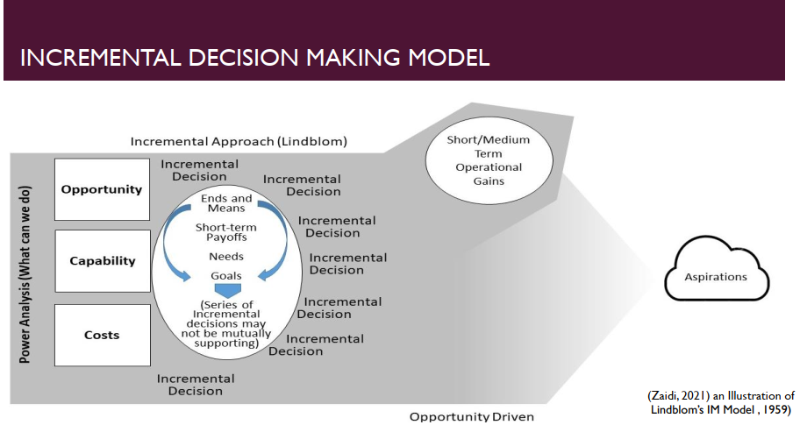

* + - * Vague points: The presence of multiple actors (as opposed to RAM where power concentreted on top to make decision) but who are these actors? How to reach consensus? Decisions are smaller that’s why it talks more about the nature of decisions.
      * Putin, does he action an opportunity? Is he an incrementalist? Can incremental model describe what we see today decisions made by Russia?
        + This model cannot explain the events of such significance. I think 2014 decision was more opportunity driven. There was a window of opportunity with uncertainty in Ukraine with political change and its consequences on Russia’s own position in Crimea. That was very crucial for core objectives to preserve the presence in the Black Sea. So that was that window of opportunity to act, and that that's was a bit more opportunistic, and using the context. While current situation I would say Russia shaped the context more. There was a a series of contextual factors that can help explain can help explain why the decision was taken now to to launch an attack on Ukraine and not for example, last year the year after. But I think it was more shaping the context taking that decision and driving it and and and the and showing that I think it was mentioned before about getting the attention. gets gets in their attention and, uh, it was last prominent in 2018. It was more contextual opportunism as I would call it.
        + Presence of multiple actors shaping for the decision. Because it is small it can happen at different levels. RAM talks about concentration of power at top which drives the decision. In this model it is more distributed. And it talks to the nature of decisions because they are smaller. There are less risks. Decisions can be rectified. So there can be more delegation than RAM presupposes. It's because presence and visibility of fundamental changes requires decisions to be escalated to the top.
        + 2022 case: we can see more active visible to Russia's FP again and then the number of incremental steps that is taken particularly in economic nature, like increases of of of prices and gas. So we can see the actors like Gasprom playing up and others putting restrictions on certain goods coming to Russia based on health considerations or tariff increase. So that was all used. These are all kind off smaller incremental decisions. And they're taking it at different organizational levels. But in Russia’s case in particular, you can see how incrementalism cannot explain the approach to DM. Because all these incremental decisions are taken by different actors. They all points set of goals that are driven by from the top. Incremental DM cannot help. FP decisions are more concentrated in compare with domestic one.
      * **Critique of Incremental Model**
        + Good options may be overlooked: Decision maker may overlook excellent policies for no other reason that they are not suggested by the chain of succesive policy steps within the context of emergent decisions and with limited analysis. But they can be rectified because of concequence of decisions which are small steps.
        + 20 years later he says not only good modelbut it is a practical implication. He insisted that it is a usual method of policy making.
        + Lack of strategic outlook: Means and ends are not differentiated. It is not goal oriented activity. So the steps are made to what is feasible at a particular point of time.
        + Notion of feasible rather than maximal policy – only part of intended consequences will be achieved: In this regard it is not aspirational model. It is pragmatic and practical model. Recognizing the limitations of decision makers.
        + Does not fit for major decisions (such as starting war, because there will be much more great emphasis on consideration of all possible consequences of options) – it is not designed to drive substantial changes
        + Presumption that past decisions, if worked in the past, will work again: Precedent based model. So it doesnt pay attention to contexual changes, one of drawbacks of model.
        + ‘policy machine in low gear, moving along a well-defined road rather slowly’ (Spanier, 1984)
        + Structural model
        + Roles of agency is diminished
    - **Blended Models:** Stays in structured parameters. Because focus on the immediate short term decisions and actions although with the strategic outlook. In Quinns model it is difficult to work outside of structures, you’re wthin. Changes may happen but slow. This is a limitation of model .
      * **Amitai Etzioni’s mixed scanning model, 1967, 1986**
        + KZ: Sociologist, attempted to capitalize on the strengths and shortfalls of both models through a blended model that he describes mixed scanning.
        + Fundamental decisions set the parameters for the numerous incremental ones: this gives strategic element. In other words, fundemental decisions are frequently prepared by incremental ones in order that final decision will initiate less abrupt, substantial changes. Incremental changes are remedial, serial and exploratory while they focus on specific heels rather than comprehensive reforms.
        + Epistemologically, scanning implies searching, collecting, processing and evaluating the information as well as drawing conclusions. So fundemental decşsşons are institutional and made by exploring the main alternatives
        + Focus on specific ills, rather than comprehensive reforms
        + However, decision maker can pursue long-term change through a sequence of moves. It brought flexibility to incrementalism.
        + Balancing act between RAM and IM. It is not qualified as 3rd model. Variant of these two foundational models. It was uselful when I was working my analytical framework.
      * **Logical incrementalism (Quinn, 1980)**
        + KZ: Quinn further develops the strategic dimension of objective setting with offering this.
        + Combines aspects of rational planning with those of incrementalism with strategic outlook
        + Most successful strategies emerge step by step from iterative process. It involves testing, experimenting, learning, and eventually leading to a strategy. Emergent strategy rather than being led by preset strategy.
        + Strategy is a pattern in a stream of action (Mintzberg analogy)

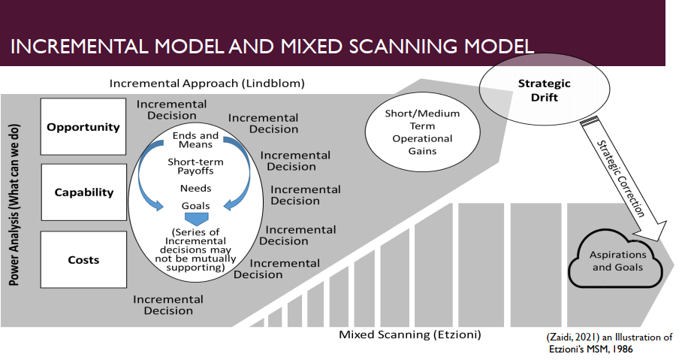

* + - Incremental model is tuned with blended models with adding systematic approach through small steps towards this towards the strategic outcome. So, incremental model becomes more linear. Incremental decisions can go various directions, there is more alignment with what what is inspired in the future. So it's a strategy that guides action actions.
    - KZ: I think the utility of hybrid models remain questionable to me, and they present an opportunity to bring twodiverse models closer together and but they still remain constrained by the common denominators of the foundational models.
    - They remain within within the foundations of two models so but they draw on strikes, one being more strategic, and another being more adaptive. So bringing them together. But they still depend on some structures, the relationship between strategy and structure and above all the diminish of role off agency keep them bounded within the decisional spectrum of the foundational models.
    - Etzioni’s mixed scanning approach
      * High-order, fundamental policy-making process sets basic directions
      * Incremental process prepares for fundamental decisions or work them our after they have been reached
      * BUT
      * Analysis is limited to the process of arriving to decisions
      * Structural model
      * Doesn’t address context and the agency of the decision makers
* **Strategic incrementalism (opportunity driven)**
  + And then I thought these were the particular weaknesses that, from my own research interest I wasn't able to apply this model to full extent, explain the action in Russia's foreign policy and and the way the decisions are made. Only and Quinn took in and trying to blend the models and I started thinking about the missing components? Looking to those models which are limited in explaining DM in Russia context I decided I can’t use them. I therefore keen with this of conceptual framework in the beginning of my analysis, which I called strategic incrementalism and that is more opportunity driven.
  + A relatively flexible model that operates within a pre-set strategic framework
    - Drawing from the strengths of incrementalism, looking at the context, but much more emphasis on the context. Environment that decision makers adopt but within the preset strategic framework. There is long term aspirations that most nations have, particularly Russia, it was profound that long view on its place in the world and what it aspires to achive.
  + Application to both fundamental and lower level decisions towards pre-set objectives
    - It is very important to look at both, fundemental and low level decisions towards the preset objectives. Because these are usually intertwined. They help to build up that knowledge, understanding why certain decisions are made, how they influence each other. And how they can help achieve preset objectives.
  + A situational model driven by context and emerging opportunities
    - It is a situaltional model, driven by context and emerging opportunities. When these opportunities are taken maybe they are not taken, and it’s linked directly to capabilities. Whether these capabilities in place to take them forward or not. Russia 2004 and 2014 are different in capability term to secure interest and particularly core interests.
  + Focuses on relationship between agency, strategy and structure
  + **Strategic incrementalism model:** Premised on five principles. Zaidi, 2021 This model has been developed with a particular focus on Russia’s FP. Case studies drives development of this concepts derived from example of how Russia takes decisions and implements its FP. In the initial conceptual framework there were four principles. 5th one added after the emprical data analysis (core interest which sits beyond moderation ~this point is critical in decision analysis). KZ argue that DM is inclined to a greater risk and the propensity for action when those core interests are threatened. This 5th one adopt the initial four.
    - **Aim and Objectives**…Strategic Outlook: Long term objectives, implemented through both fundemental and incremental decisions.
      * Decisions are selectively emergent, guided by a predetermined strategic direction. How far a direction can be rationally travelled (ends) is moderated by capabilities and context.
    - **Agency & Structures:** Role of agency and structure in decision-making is balanced by the type of actor within the obtaining environment. Agency will play a more profound role in systems where leadership comes from a narrow group or even a single person at the top; the more hierarchical structures are, the more dominant role agency will obtain. Decision analysis must take into account the degree to which agency prevails. When high degree of agency exhibited by an actor, historical patterns in decision making become less relevant and the agency’s perspective becomes more dominant.
      * An example of Russia, but also in in other more democratic regimes, where we see a sort of dominating role of executive in decision making, particularly when it comes to foreign policy. So that's why an analysis we need to look at at what sense that? Agency dominates the structures or it chooses to work with or be supported by structures. Trump ignores the structures and Biden approach ~ work with structures.
    - **Strategy & Structure:** Agency, if dominant over structures, may innovate, disregard or create structures to drive strategy. Indeed, it may also choose to work within structures for practical or political reasons. Conversely, where agency is diminished, structures may dominate strategy.
      * They have a preset objectives. What they want to achieve, how they want to do it? And they modify structures to help them.
    - **Interplay between capability & Context** in nation’s pursuit of its strategic goals. Balancing between agency, structures and strategies … ‘Doability’
      * Opportunities that advance existential strategy are exploited after due consideration for prevailing risks and long-term payoffs. The decision-maker exploits opportunity when strategically prudent in a given context and obtaining environment.
    - **Focus on Core Interests** (Strategy Adapts to Protect Core Interests): And above all, we see how crucial it is to understand and act as core interests which tend to remain consistent being long term and are unlikely to be moderated,
      * Recognition of Core Interests that sit beyond moderation is critical in decision analysis. An actor is inclined to greater risk-taking and propensity for action when inaction threatens a nation’s vital and core interests.

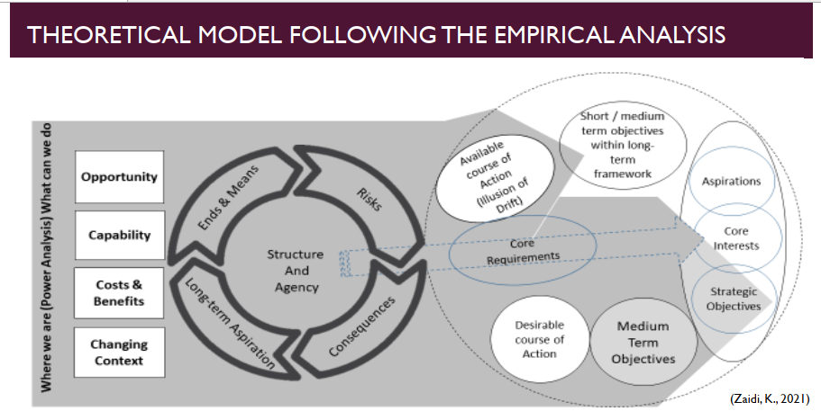

* + On the left side we see the drivers each of which goes through the analysis stages represented in the middle donut. For example, emerging opportunities are assessed against the risks, consequences, their relationship to LTA, means to consider to take the opportunity forward.
  + The way the process is done depend relationship between agency and structure. It can be done differently in terms of risk analysis, consequences, what extent it’s driven through structures and certain steps or agency where the values, beliefs, and personal biases come into play.
  + Resulting output is either in action because it might be more prudent not to take any action if environment so suggest, or actions or series of actions are taken along available courses within obtaining environment.
  + These are ultimately connectable with LTA. All actions are driven towards that right side, dotted circle. Even if they are small steps or fundemental changes, they all in there kind of totality they lead towards that aspirations and strategic objectives. Difference is
    - When the core interests are concerned, the action is decisive. So protection of pursuit of core interest will always prevail over risks. That’s why we see direct link. But for this core interest there is a need for core requirements to be in place. Core interest of Russia to preserve in Crimea is continous access to black sea through global world waters. Core requirement of this core interest is unconstrained access to black sea and azov. Given that req, how Russia protect its core interest, and when it felt that it is threatened, it took decisive action rather than small decisions.
  + This model remains exploratory would benefit from further testing. Using different case studies, and grounded theory methodology, can help refine model. Theoretical concepts are not static. They evolve over time. That’s why I prefer grounded theory approach. It is robust methodolgy because you go into detail of data. You have to test it all the time. Process of iteration is ongoing. Where theoretical concepts are not robust enough, from qual methods this is the robust one to explain the events.
  + Comparision: RAM goal driven whatever the context is,
* 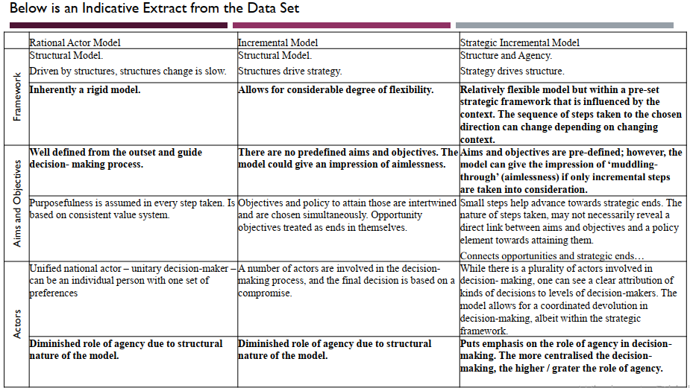

F

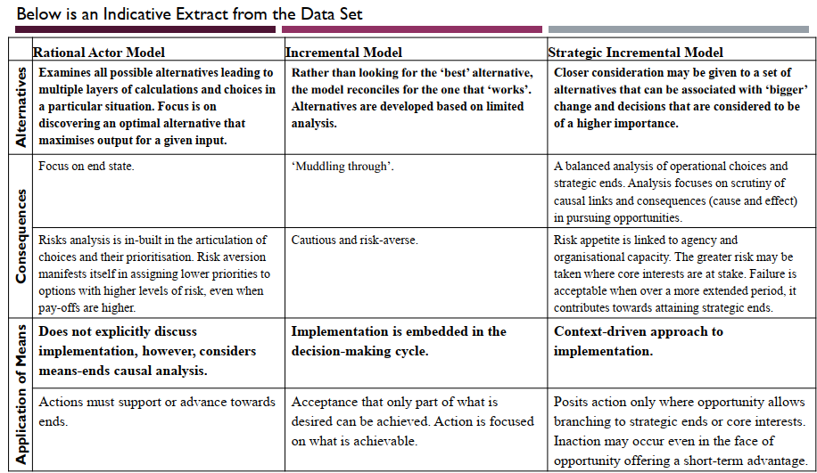

* + Summary
    - SIM major distincyive feature: What happens in 2022 arguably demonstrates the validit of this model. is also structural but balancing the role of agency and structures,

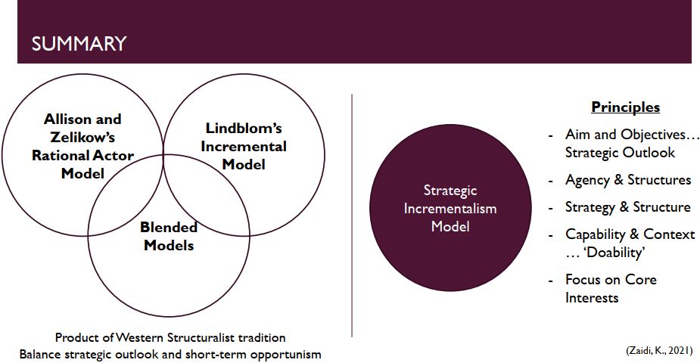

* + KZ Research Approach:
    - I think it's also shows again that there is no ideal model and and the models have continued to evolve and and it's useful to look at the variety of models available to try to understand what is the best conceptual framework that helps us take through that particular analysis.
      * First thing is looking existing DM models.
      * Then I identified two foundational models (RAM and incrementalism) I thought can help me to build my own theoretical framework, drawing the strength of these models but also very much on the critique.
      * What I saw were missing elements. After having built conceptual framework KZ used grounded theory approach, a little bit step aside methodology, testing conceptual framework via data. To gather data and apply it to the conceptual framework and see whether this conceptual framework works or it needs further refinement through data.
      * My starting point was not to build a new model. But I came to conclusion that they have limitations. That's why that theoretical framework continues to evolve. RAM, bounded rationality, incrementalism and so on, branches of RAM, so it's a constant refinement.
  + Strategic goal Russia: regaining global pwer and increase the area of influence,
  + Core interest: One protects immediately. It takes decisive actions. Crimea wasnt complete. Lack of land corridor makes russia vulnerable. Protecting core interest, started 2014 and continues. Core interst is securing the access to black sea and wider.
  + the importance of that systematic approach when we analyze a vast amount of information so to predefined questions and sort of In setting up the the indicators for their analysis is quite useful, and then taking them systematically through case studies, case study analysis in the case

of Russia's foreign policy, either it was Moldova or it was Ukraine or Armenia. So I applied the same set of indicators and then you can start comparing, because otherwise it's so much information out there and and it's hard to select. It's just to remind that. What I I what indicators are used in in an analysis and this links back to the to the theoretical framework and and what because they derive from theoretical framework in terms of. For the main parameters for analysis, so this is just a very brief example of a documents that were used,

Emprical data from: strategic documents overtime, interviews, speeches, You can start building a more comprehensive picture through triangulating these sources of information. Because none of these sources will give you the true picture. And even there is a level of interpretivism. In a combined way this is mitigated. I looked at the documents, looked at what's been said all the time and in trying to define So what are the aims and objectives, how they've been moderated over time and and, and what I concluded is that that there is a really high level of consistency and in Russia's foreign policy aims and objectives. 2008 they say multiple polirity. Russia FP is determined by long term interests and by tendencies n global development. FP is facilitating factor for achieving national interest. New FP 2016: Securing securing its position as one of the centers of the contemporary

world to strengthen its position as a kind of a of Russia's culture.

it's a broad. Sense of hard and soft power, uh, sort of interplay here and.

In Ukraine case how CIS take position? Consistent, Russia see them as strengthening its regional position. Through the collaboration, and advance integration within CISA. Undermining that integration process is seen as athreat. EU and NATO is rival in this context. Russia takes that longview. Evident in docs and pol rhetoric.

Act as agency: Putin, is main decision owner, his role strengthened overtime. Emphasized str docs as well. He both sets up the agenda. And drives impl. Seek advice from security council or foreign min that he chairs. But less evidence in playing role. Calculus approach to FP, driven by interest, churchill 1939, russia is enigma, if you look national interest you can strat understanding what drives it. First look core interest to explain the action. Munich in 2007 that there is nothing personal in international relation. That's simply calculation. But there is of course personal. A lot. We've see it now in Ukraine. It's very personal to him to his vision of how he sees the role of Ukraine in achieving Russia's policy.

So it's very much internalized for him. So there is always personal aspect of this. Calculus approach based on personal interest, asprations and view of world.

We see also agency: Collapse of soviet union, major geological disaster. Explains the rationality of some decisions. Former soviet is Russias sphere of interest. For baltic states in 2004, russi was not in position to act. Combination of capability and context. Baltic states do not play crucial role in Russias strategic interest as Ukraine does. St petersburg sea access. South is much more vulnerable.

BIBLIOGRAPHY

Amitai Etzioni (1967) “Mixed Scanning: Third Approach to Decision Making”, Public Administration Review, Vol.27, No.5.

ALLISON, G. and ZELIKOW P. Essence of Decision. Explaining the Cuban Missile Crisis, 2nd edition, New York, Longman, 1999.

*1999 edition of Essence of decision contains RAM and other two models.*

Barber, H. F. , (1992) “Developing strategic leadership: the US Army war college experience”, Journal of Management Development, 11, pp. 4-12.

Bennis, W. and Nanus, B. “Leaders: The Strategies for Taking Charge”, New York: Harper & Row, 1985.

Charles E. Lindblom (1965) The Intelligence of Democracy. New York: Free Press.

David Braybrooke and Charles E. Linbdom (1963) A Strategy of Decision. New York: Free Press.

Fred C. Lunenberg, (2010) “The Decision-Making Process”. National Forum of Educational Administration and Supervision Journal, Volume 27, 4

Graham Allison and Philip Zelikow (1999) Essence of Decision. Explaining the Cuban Missile Crises, 2nd edn: New York: Longman

Allison, Graham T. “Conceptual models and the Cuban Missile Crisis”, American Political Science Review, Vol.63 (September 1969), 689-718.

Janice Gross Stein (2012), “Foreign policy decision making” in Foreign Policy: Theories, Actors, Cases, Smith, S., Hadfield A, Dunne A. (eds.), Oxford University Press

Jervis R. (1976) Perceptions and Misperceptions in International Politics, (Princeton: Princeton University Press

Jonathan Renshon and Stanley A. Renshon (2008) “The Theory and Practice of Foreign Policy Decision-Making”. Political Psychology, Volume 29, Issue 4 (2008)

Lindblom, C. “The Science of Muddling Through”, Public Administration Review, 19(2), 1959.

Strauss, Anselm L.; Corbin, Juliet M. “Basics of Qualitative Research : Techniques andProcedures for Developing Grounded Theory”, Sage Publications, Inc, 1998.

Putnam, Robert D. “Diplomacy and domestic politics: the logic of two-level games”, International Organisations, 42: 3, 1988.

Rummel, R.J. “Understanding Conflict and War, Vol.4: War, Power, Peace, Sage Publications, 1979.

Simon H. (1972), Theories of Bounded Rationality, in Simon H.A. (1982) Models of Bounded Rationality: Behavioural Economics and Business Organization. MIT Press, Cambridge, MA.

Simon H. (1985) ‘Human Nature in Politics: The Dialogue of Psychology with Political Science’, American Political Science Review 79; Herbert

Simon H. (1982) Models of Bounded Rationality. Cambridge: MIT Press.

Zaidi K. (2021) "Approaches to Decision Making in Foreign Policy: Literature Review", Journal of Political Science and International Relations, May, 4(2): 48-55 DOI:10.11648/j.jpsir.20210402.14

Zaidi K. (2021) “Russia’s Foreign Policy Decision-Making. Case studies of Ukraine and Moldova”, International Journal of Social Science Studies, November, Vol. 9, No. 6

Policy, Strategy and Change

Strategy development

SPD Module

Dr. Iftikhar Zaidi

Bringing together strategy, policy, and politics

* Meaning of policy and strategy in business and military perspectives:
  + Concept of strategy remain unchanged (military or business)
  + Role of policy: guiding light for strategy (At the fundemental or theoretical level).
  + Business area the meaning of policy and strategy gets a little distorted. Because unlike a national context where you’ve the people that are really source for driving policy in the first place, policy is just a perspective of translating what the people aspire, national aspiration, sum total of the wishes of the majority in a democracy. But also moderation of that, those that may not, favor a particular government or particular perspective, but everybody has to go along and that’s something we bargain in a democracy.
  + But in business, board exist for profit. There policy is essentially not in essence as long term as state may have. And they may confuse policy and strategy and use language interchangeably. That’s why we do not hear the word policy in business world. In fact number of scholars refer to policy as the strategy of the higher level. So if the corporate level has a strategy, then the business and the functional unit level the strategy of the corporation becomes a policy, and then those business units evolve their own strategies.
* **Essence of strategy**
  + What is originally intended by strategy? Before it adopted and modified in the business world.
  + Aim: Explore strategy, strategic thinking and strategy development.
  + Learning Objectives
    - Describe strategy, strategic thinking and strategy process
    - Appraise principle notions and fundamentals of strategy and apply these in strategy development.
* **1. From Policy to Strategy:** 
  + **Reflections on the chart**

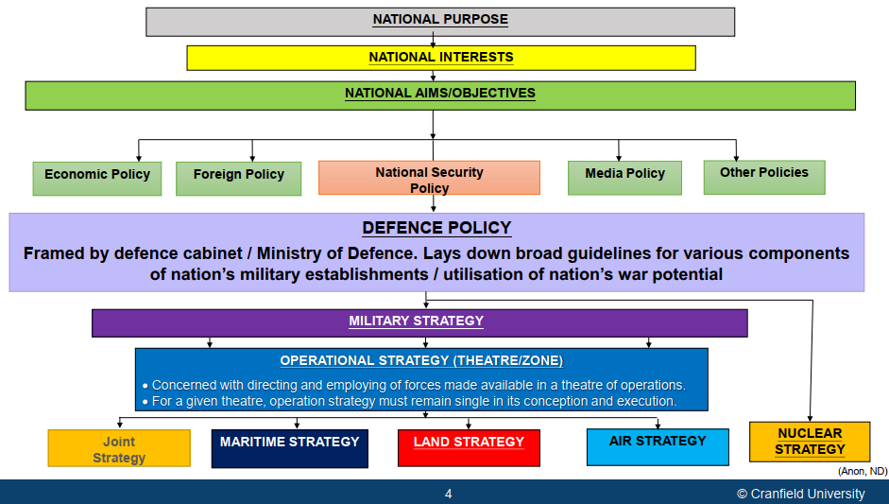

* + - At the heart of everything is national purpose. Why does the nation exists. It is the product of or sum total of the aspirations & wishes of the people. It is embedded in the population. The constituency that the nation serves. Where they wish to proceed in the future.
    - National purpose is translated to national interest which we then become national aims and objectives. This is where the role of governents begins to come in. Governments start with green box and translates national aims and objectives into policies. We then transition from policies to more granular level policies eventualy into strategies that are precursor to the plans before action.
  + **Spectrum (levels) of strategy** (UK Perspective):

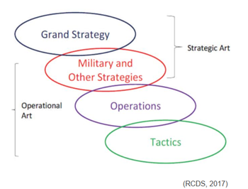

* + - **Grand strategic level:** the responsibility of Her Majesty’s Government – is the national political level that sets the government policy on international issues, in effect national aims in peace and war that strategy is to deliver.
    - **Strategic level:** Departmental level strategies (in the case of the military it will be **military strategy**). This is the responsibility of the Ministry of Defence – is the highest military level, developing, sustaining and assigning military forces to support government policy and achieve goals set at the Grand Strategic level. (Military translates those strategies into operations and then eventually in the field of action they are the realm of tactics).
    - **Operational:** the responsibility of the Permanent Joint Headquarters (PJHQ) planning military campaigns and deploying forces to achieve the [military] strategic objectives set by the MOD. There is people in uniform and they start translating strategic level (MoD) strategies into operational strategy and and tactics.
    - **Tactical:** the responsibility of Field Commanders or Component Commanders – directing operations on the ground, at sea and in the air. Tactics is where;
      * conceptual thought (why and what) needs to be done gets translated into *how.*
      * plans translate that what and how into actions. (RCDS, 2017)
    - Essence of grand strategy is integrative. It is a conceptual. The system, a set of interdependent elements where change in some elements of their relationship produces changes across the system as a whole, and the entire system exhibits properties and behaviors different from its constituent parts. So it's like a complex adaptive system.
  + Another way of looking to flow diagram is spectrum of strategy



* + - You have aspirations, purpose, aim and objectives, more or less consistent at a given time, and these change slowly over time, embedded in history, in culture, in tradition.
    - Then you have political elite, in the form of political groupings, parties, brings their own prism to make sense of what this means.
    - Then each prism then translates aspirations to intent in a unique way. This transition from aspirations to intent is what we refer as policy.
    - Coloured spectrum: Policy is meaningless unless it tends toward action. Political intent must then be translated into action, that’s where the role of politics also comes into play. Political particularism translate those intent into grand strategic, strategic, operational and tactical levels of action. Tiniest change in policy would make enormous change in coloured spectrum. It amplifies because of interdependence, language of complex adaptive system.
    - Policy dominates strategy by its articulation of the **end-state** and its guidance regarding **resources, limitations on actions**, or similar considerations’ (Yarger, 7)
    - Grand strategy is the intellectual architecture that gives form and structure to strategy, operations and tactics.
  + Strategy at its core, is about;
    - Balancing ends and means: strategy has certain resources put at its disposal and certain ends that it must produce with these resources. It is really in essence about how do we best make use of resources to deliver the ends.
    - Ways
  + Although everyone can see the outward aspects (tactics), none understands the way (strategy) in which I have created victory. (Sun Tzu, 100)
    - IZ: What we see are actions on ground, but it is very difficult at times to look at those actions and try to relate those back to the strategy that might be driving each of these actions. Sometimes in the absence of good intelligence, you have nothin to go upon then to look at what an adversary & ally is doing and try to make sense of what is in their head. This is that ambiguity aspect of the VUCA world.
  + Strategy is simple, sometimes the simplest things are the most difficult. Clausewitz, p.178
  + Non military mean of word “strategy”?
    - Strategy is an approach towards achieving an expectation.
    - IZ: it is about this word cloud. These are the words associated in business world. In military it is slightly different. Because everything is context dependent.

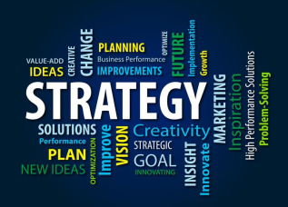

* + - Strands like: *Long-term thinking; a policy or approach; a stratagem; a scheme for success; activity involving investment; ends, ways & means…* are on the ‘right’ lines.
      * IZ: Stratagem is how do you trick your adversary into doing something that they shouldn’t have done. Doing something that puts them at disadvantage. In other words, by putting somebody else at a disadvantage, you create more advantegaous position for yourself. So it not about coming at clash against somebody, it is about clearing the way as much as you can, so you have least amount of resources spent as you navigate.
      * IZ: It is about developing creative ways of achievin ends.
    - Common to all interpretations is the supreme importance of strategy as an ***enabler*** *of success*; a view shared by academics, the corporate world and the military.
      * IZ: Without a strategy you will end up banging head on, drift in different directions away from where you should have been going. So it is what keeps efforts purposeful. Especially when efforts includes multiple actors (different source of power, different strategic lines, different lines of operation must interact, contribute one another iot produce outcome).
    - A plan without strategy wanders aimlessly, *it is the noise before defeat* (Sun Tzu).
    - Strategy drives plans, Clausewitz. While no plan survives contact, a good *strategy is resilient*, and relevant even when a plan fails.Moltke the Elder, Helmuth von Moltke (1800–1891)
  + Etymology:
    - Origin: 1680–90; < Gk **stratēgía** generalship, equiv. to **stratēg(ós)** military commander, general; (strat(ós) army+-ēgos n. deriv. of ágein to lead)~Orduyu kullanma&liderlik etme, harp idare sanatı & generallik sanatı
      * IZ: The word comes from military, it means the way of the general.
    - **strat‧e‧gy** – noun, plural **-gies**.
      * the science or art of combining and employing the means of war in planning and directing large military operations.
      * the use or an instance of using this science or art.
      * skilful use of a **stratagem, subterfuge, ploy, machination, ruse, trickery or manoeuvre**; e.g. *Napoleon’s favourite ploy was to use baited gambit to draw the enemy into strategic making blunders*.
        + IZ: Military meaning. Overlaps: In competition strategem and subterfuge employed, a trick iot imbalance the opposition.
      * a plan, method, or **series of manoeuvres** or stratagems for obtaining a specific goal or result
        + IZ: This is where IZ depart from dictionary meaning. In academic speaking we should stay as far away from dictionary meaning of terminologies as we can. They tend to be not in the context of the subject. Rest of the sentence is right, but “plan and method” part, IZ has objection.
  + Strategy has military origins, but it’s used extensively.

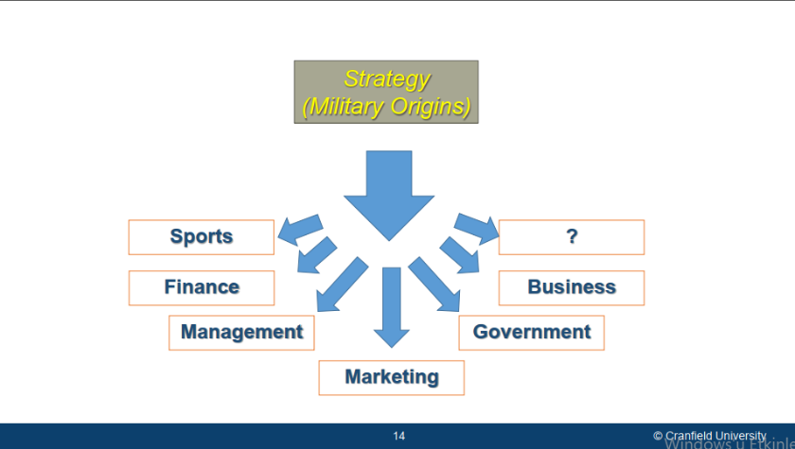

* + - For the left part, IZ wonder if they are taking us away from the meaning of strategy, sports team has strategy or you can have strategy for even the oddest thing like breakfast. So lets have a definition.
  + **Definition of strategy:**
    - “The **determination of the long-run goals** and objectives of an enterprise and the adoption of **courses of action** and the **allocation of resources** necessary for carrying out these goals.”(Chandler, 13)
      * IZ: One of the earliest adaptation of the term from military to business. Chandler in many ways seen as the father of the modern enterprise. Because he provides the fundemental components of strategic management that enabled mega corporations to emerge and thrive. This definition comes after he analyzed US firms and military. This definition has nothing to do with what’s going on in the present. And it has nothing on operations or tactics.
      * Purpose of strategy is to create new organization that it fits for dealing with challenges of tomorrow. He is talking about organizational development and structure, restructure and change.
      * One of his thesis was strategy must dominate structure. Successful organizations first develop strategy, then they adapt their structure to deliver that strategy. Less successful organizations are rigid in structure. They try to apply new strategies through old structures that weren’t designed to apply those strategies. He argued that’s where things begin to go wrong. Because strategy and structure are in a deep relationship.
      * His notion was argued and contested later on and people like Mintzberg and Porter. They came up with the idea that in a complex and fast moving environment, strategy can change, but structure must remain consistent. So therefore strategy must be made subservient to structures that are present. They agree that structures would obviously need to adapt, but you cannot change structures as quickly as the environment might be changing in certain contexts.
    - ‘Competitive strategy is about being different. It means deliberately choosing a different set of activities to deliver a unique mix of value.’ Michael Porter
      * IZ: VRIO framework, you have to create something unique, if you do not create something unique and if you are small then you are never going to compete. And therefore strategy is all about being different. Deliberately choosing something that you can do better than others and making sure that you excel at that.
    - ‘A pattern in a stream of decision’ Henry Mintzberg
      * IZ: Mintzberg recognizes strategy as a as a futile but important activity. It is futile because it's never going to be played out in the manner it was conceived. Future is not known, strategic challenges and shocks will impact original strategy. So therefore that original strategy what he refers to as intended and deliberate strategy must adapt and the adaptive strategy that actually gets played out. He refers to as emergent strategy,
    - Strategy is the **art** of **distributing and applying military means** to fulfil the **ends of policy** (Hart, 321)
      * IZ: See this because classical ideas and strategy are now beginning to come back. Because we see return to land warfare. We see classical continental type strategies with resurgent Russia. It is an art at least west has over the years forgot.
  + **A Working definition**
    - Strategy is dynamic, logical and conceptual, pitted at every stage against an ***active, intelligent and opposing mind set***, applying (and developing) instruments of power for **creating moral and physical effects** to advance those policy ends that the strategy serves. Strategy achieves (current and future) **objectives** (ends of policy) through the development and application of **ways** and (using) allocated **means**. (Zaidi, 2009; 2020)
      * IZ: Strategy, at any given stage is about ways. Objectives, resources, and constraints are driven from the top. So, at any given level, you’ll only be dealing with ways.
      * **Operational Dimension of this definition**: A short term perspective that focusses on innovative application of relatively fixed means to deliver specific ends as defined and constrained by policy; focusing on **‘*Ways*’**, it relies on concepts, doctrines & creativity.
      * **Developmental Dimension**: A mid to long term perspective concerned with future threats and the ***development of means and way*** to achieve and inform future capability. Ends, ways and means form a dynamic function that informs policy.
        + IZ: But because often the conceived ends are a product of what the original analysis conceived would be the available means and and the likely ways, therefore overtime the three items (ends, ways and means) become mutually informing or interdependent. Interactive scenario:

Ends can evolve as a result of means increasing or they can diminish as a result of means decreasing.

They can evolve as a result of ways becoming successful and in a competitive sense better than your adversary. But they can also diminish because your adversary has just discovered how to counter something you’ve been developing for a while and you’ve lost that advantage.

* + - * IZ: Another thing in this definition is opposing mindset. You have to deal with opposition. An agent. An agent. That agent has a mindset I can defeat that agent. Therefore in one of two ways I can defeat that agent, either psychologically or physically. What you have is a dialectic of two opposing minds.

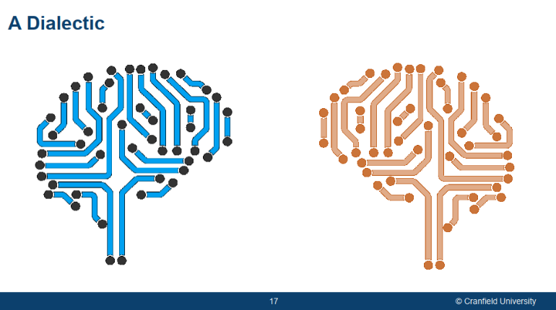

* + - * + Earlier definitions do not seem to capture this dimension. This is of particular value for my topic of moral factors in outcome of battles.
  + **Ends, ways, and means:**
  + Strategy is the sum of ends plus ways plus means.

Ends + Ways + Means = Strategy (Lykke, 1989)

* + - IZ: Now I've never been a fan of this statement and I've I used to laugh when I read this for the first time back in 1989. That means if I have no ways of doing something that is ways are zero, but I have 20 ends and 1 means therefore my strategy is equal to 21. So mathematically this is quite silly.
    - Even, to think of strategy as a product of ends, ways, means to me is quite alien.
    - IZ: Strategy is the bridge: Where are we and where do we want to be?
    - The ends to be achieved comes from top it is given, we have no control over this.
    - What means are needed to get there also ALLOCATED from top)
    - Only thing that we are left with is ways (What to do and Why). So it is creatively apply Means to achieve Ends.
    - Equation of strategy of IZ which was ends are a function of ways into means.
      * This word **function** captures turbulence, the sum of VUCA, friction, chance, the moral component, leadership and information, subterfuge.. All of those things that must come together in order to produce a meaningful capability. And that’s what ends will be governed by. This equation is a complex one and in many ways contextually dependent set of variables.

Ends ***ƒ*** Ways x Means, Leading with Strategy, Dr Ifti Zaidi (2014)

* + - * Other important considerations that strategy must answer.
        + What turbulence, active opposition is to be expected on the way?
        + How do I know I have arrived? 2003 Bush declared victory in Iraq War. How far from truth was that? Next 17 years US continued fighting.
      * Incorporation of these risks: Strategy being protected by long term so a lot can change. Politics and policy can change. The ends can change even if the policy remains constant. So with every long term interaction to an extent short-term 1 as well, albeit to a lesser degree, they're always risks associated. These are;
        + Ends related risks as **Re**
        + Operational (Ways & Means related) risks as **Ro**
        + Equation become slightly more comprehensive.
* **2. Strategy and Organisational Development**: 2 dimensions. In the short term, trying to use what resources and what means and what ways are made available to the executive iot achieve immediate and short term objectives. Development of the organization to make sure that it is prepared for future threats of over the horizon.
  + **Strategy in the short term perspective**: strategy is about these five **components of strategic decision.** 
    - **Strategic posture and transitions**
      * What should be UK strategic posture? Tony Mccane argued UK posture would be whatever US decides is the strategic posture but with the commitment that it will go in first. And be able to deploy alongside the US. UK decided strategic posture that was subservient to another part.
      * A posture cannot last forever. It has to change. Sun Tzu warns that, “if you’re constantly on the offensive, you will weigh yourself down and any victory that you’ll achieve will eventually become the root of your defeat.”While you make yourself invincible in defence, you’ll never attain victory, because victory is only possible through offencive. Each transition of posture needs decision of when is the right time?
    - **Distribution of effort** (How do we deal with resources of DIME?) to subordinate levels. With reservations.
      * At diplomatic level: To get something at national level you will task diplomatic manuover to achive en state. And, economic, informational, and military contribution & manouver to support diplomatic efforts. Who is doing what in attainment of end state.
      * Resources as risk carrier as the ultimate arbitrator do you hold and use in case you need to get to resolve unforseen situations.
    - **Strategic Direction Lines and Approach broad timings & linkages**
      * What direction to take. At tactical level, left, right or center? At strategic level they become to direct or indirect action. Use of soft or hard power.
      * What are the connections in each of these?
    - **Task:**
      * Comes from top, often vague. You’ll often translate intent into objectives for yourself. You need to do comprehensive task analysis.
    - **Capabilities:**
      * In the short term you cannot create capabilites or organization, systems and processes. You can only regroup and refit. You cannot do Joint Force Development or restructuring.

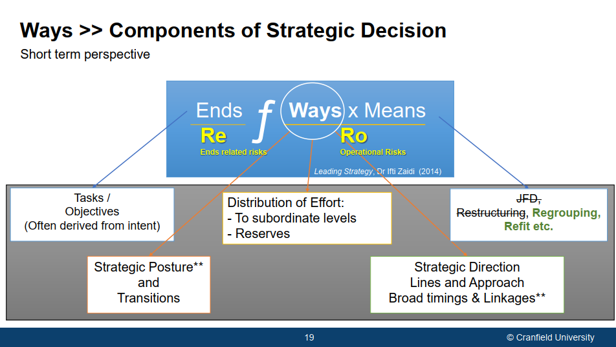

* + **Strategy in the long term perspective:** We are looking ends projected over a longer period of time. We are trying todevelop the organization in terms of developing capability which translates into ways and means. So we will apply means today to achieve greater Ways and Means for tomorrow. That really is the main difference between these two perspectives tasks.

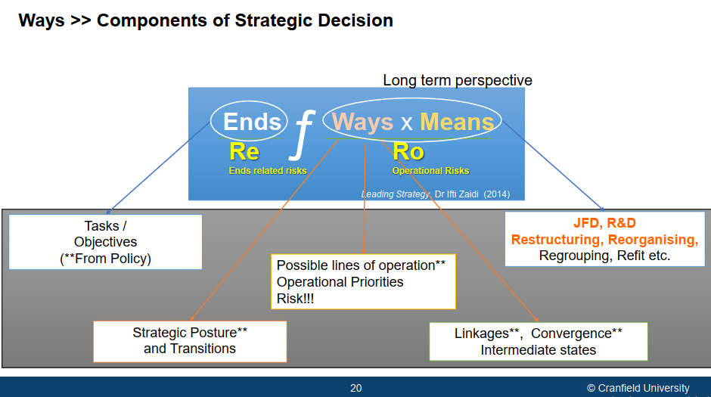

* + - Tasks / Objectives of Policy: Comes from top.
    - **Ways:** Remain more or less the same.With language slightly different. Like “possible” postures.
      * **Strategic posture and transitions:**
      * **Possible lines of operation**Operational Priorities Risk!!! :** You look at possible lines of operations because what may not be available to you today (in terms of means) after development might be.
      * Linkages**, Convergence**, Intermediate states: That is, how do different lines of operation compliment one another where our developmental capabilities converge (concept of convergence). It is linked to intermediate states.
    - **Means: You think long period everything is open** 
      * **JFD, R&D Restructuring, Reorganising**, Regrouping, Refit etc
    - So in the long term ends Ways and Means all become mutually informing and they become more deeply interrelated.
  + **Short& Long term summary:** 
    - **Short term** is all about ways, the bit in white. Means and ends are relatively fixed. It is about being effective, efficient, and accountable. Module 1: This is what managers do. Managerial perspective.
    - **Long term**: Ends, ways, and means become mutually informing. While you strat with percieved fixed ends, it is still dotted, because how you progress on the journey of developing Ways and Means will also impact the ends, and indeed of course the external environment will impact on the end. so this is about future proofing the organization. It's about organizational development. It's towards a new set of capabilities. In other words, it's is change and movement, which is what we refer as a more leader like activity.

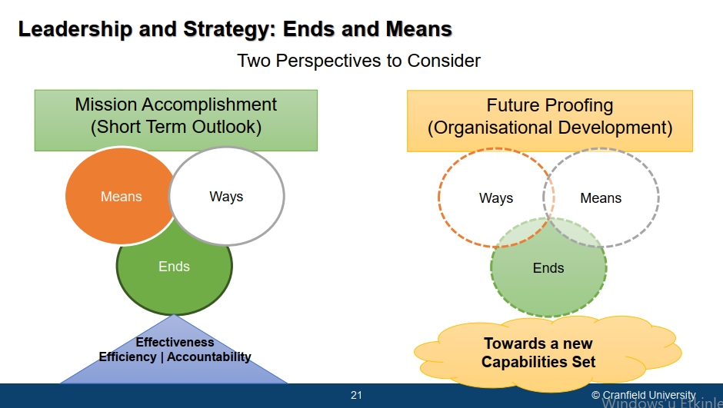

* + **Two trends of organizational strategy**

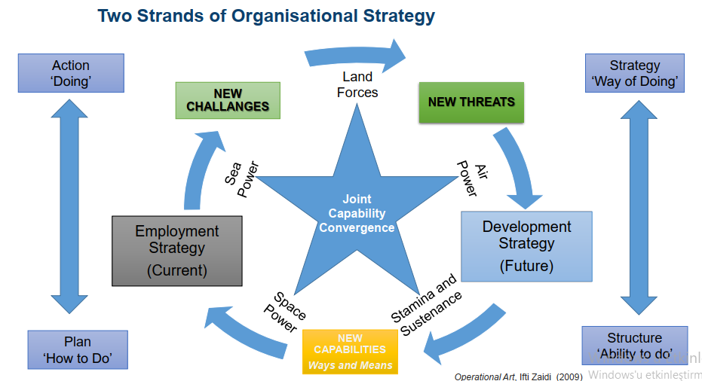

* + In the short term, we have our plans how to do and then we put those plans into action that is doing we are fit for purpose.
  + In the process of doing we encounter new challenges and we find that what we were trying to do doesn't work anymore. New threats begin to emerge or get recognized. We find that the organization, unless it changes it becomes unfit for purpose. So strategy, our way of doing and the relationship with structure, ability to do, start interacting with one another in a complex way which produces our recognition of those problems.
  + So what do we do? We need to build new capabilities, and these new capabilities then bring us over time back to being fit for purpose.
  + And obviously, if you're doing this continuously, in a both a graduated manner and, then that is, Gemma’s graduated paradigm and the punctuated equilibrium paradigm. That's how those two paradigms coincide with one another to allow you to go through this cycle.
  + But the ultimate aim of the cycle is to produce joint capability convergence. What it means is that convergence only exists that if the land, sea, air, space and logistics are able to contribute to one another. So this includes the comprehensive sum of capabilities of sea, land, and others be aligned at the same point in time.
  + There is no point in the Air Force being ready for operations 20 days from now. The Navy being ready today and the operations happening day after tomorrow. Only navy ready. So what that means is you've left the Navy on its own.
  + So when we develop capability, we need to make sure that our employment strategy, current strategy and future development strategy has a planned, synchronized, and well considered journey. Capabilites develop simultenaously. That is the notion of convergence.
  + What convergence implies that is your legacy capabilities where you're unfit for purpose and things that are in the making but not yet made have a huge journey in between. That creates a gap. And this gap is the gap here (spiral in cube).
  + So plan “how to do” part is your capabilities today. “Strategy “way of doing” part is the capabilities you wish to achieve to be fit for future tomorrow. If I was your enemy, I will capture you somewhere here in the middle. When you're neither here nor there, but I will make sure that my capabilities are accelerated to be able to defeat you somewhere in the middle.
  + So what we need to be able to do is to recognize, keep that eye on the active opposing mindset and develop capabilities that can match and deter that adventurism in your journey from where you are today to where you want to be.

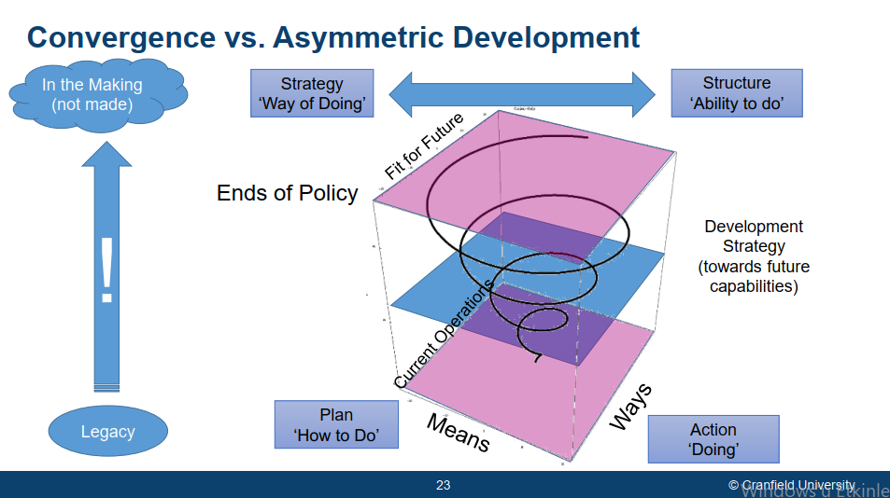

* + **Instruments of power:**
    - **At the operational level:**
      * Instruments of combat power (means or available resource) consist of man, machine, materials, and time. **3MT** These are the commanders things to play with. Interplay of these things. Standard resources that organizations employ iot achieve strategies.
      * BDD, 2003 producing interesting twist on this. **3MT** implies a completely mechanical process, only means are emphasized. Get these right and win. It says it is a bit more than this.
        + Samurai soldier anology to explain this. Soldier with weapons, armoured, clearly well-fed & trained. And with the eyes, teeth we see desire to put these weapons to good use. This is combat power in nutshell.
      * BDD argues that combat power is a sum of;
        + **Means to fight**, things that we need to fight with, like soldier, weapon, armor, iot feel the capability. The physical element of the capability. BDD refer this as physical component.
        + **Know how to fight**? You also need to know how to use these things. How to get the soldier supplied. How to use weapons. Right kit for right occasion. How to fight is intellectual capacity, software of the mind. This is embedded in the organization in the context of doctrines, principles, SOP’s. Better use of the means creates better effects. BDD refer this as conceptual component.
        + **Will to fight**.This is the hearth of the fight. If there is no will, first two becomes meaningless. IZ: I would rather have a stupid soldier, poorly trained, with nothing but with fists, but with a hearth the size of a lion. Because that soldier has will to fight. BDD refer this as moral component.
        + Ideal situation is to have all of them in good measure. The more of this is better.

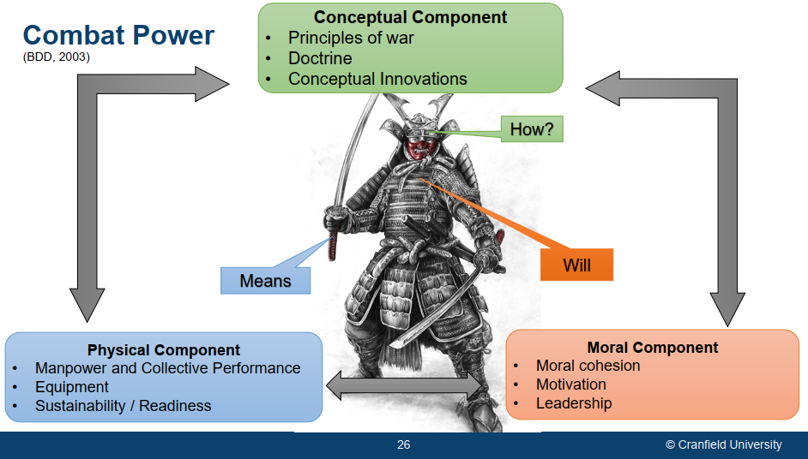

* + - **At the national level:** 
      * Instruments of power is not 3MT. Not just conceptual, physical, or moral component. But they are **DIME**.
      * These are DIME. But all these four is captured within culture. IZ: Culture is equally important component of national power.

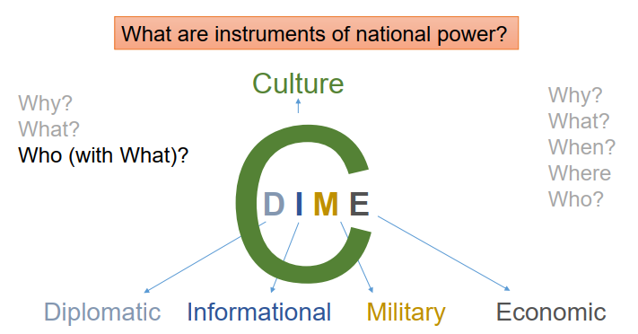

* + **Scenario Building:**
    - **Future** (behind vision): Not possible to estimate future exactly. Even the knowledge of present is imperfect. So when predict and plan for future we wil likely go wrong. We can work with possible futures. These possibilites are scenarios that emerge. In these scenarios there is interplay of opposing mindsets.
    - **Turbulance:** Is benign and just simple friction and fog.
    - **Detrimental:** Active interference, somebody who's interested is to make you fail.
    - **Probable future** (black oval): If htere is no change and no proper strategies, you will end up in the probable future. But opposition will try to make sure that it is detrimental. In other words, they will want to clear their way.
    - **Vision:** But we have a vision, and our vision is to arrive in front of future. To arrive at this vision, we must contest with the opposing mindset. And we must apply means and resources to develop our organization on this journey with as little interference along the journey to achieve a vision.
    - **Realizable vision:** Portion of the whole vision which is achieved with the given resources.
    - **Organizational development:** It is that always floating to an extent that we are aiming for in in the long term (the associated risks cause that).

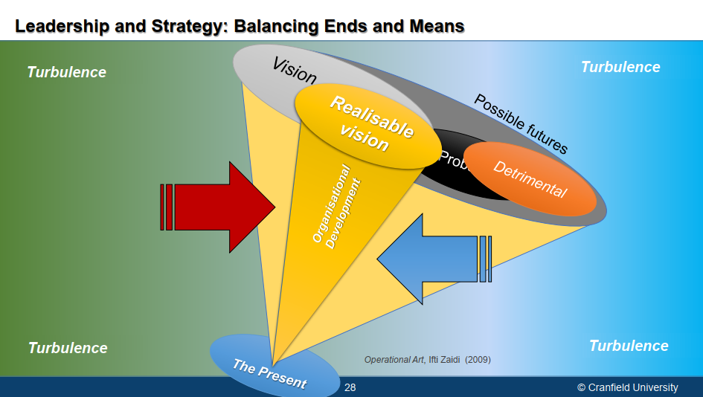

* + Strategy Development:
    - Evolution of policy starts with the **white light** (aspirations, national purpose, aims & objectives) embedded in people as Clausewitz says.
    - And there is **elite politics**. Although we assume that, in rational process, people dimension, will translate the policy through this process in a triangle (policy), but there is political or elite particularism & interest, not necessarily people in power, but people associated with power, the kingmakers, who use their influence to moderate policy to suit their interest.
    - Political particularism produces its policy, and it is never perfect product of rational analysis of all of these factors.
    - When you get policy, you can start with **strategy formulation** to put into practice (**strategy implementation** in chart), and try and edge closer from intent to action and from action to aspiration.
    - Strategy is not about processes like step1 and step2 so on. If there are steps then it is process. We interest with what it means and the key components that strategy must consider to overcome and intelligent, opposind, and reactive enemy mindset (purpose of strategy). So this is interactive, competitive environment. In this environment you have to have the dialectic of opposing mindsets. And you are trying to overcome other mindset. That is the object of the strategy. It is not a process. How do you do that, how do you subterfuge, that is the part of strategy game. In this competitive environmet you can defeat enemy psychologically also physically. Usually combination of these two is needed. Purely physical approach, more mis understood Clausewitzian, which seems to US prefer I would say, doesn’t always produce the right results. People like lee j. Krajewski or lidell hart, psychological side, deep dive into sun tzu also emphasizes this. It is the will of the enemy that you must defeat, not necessarily their means. Because means can be recreated. True victory emerges with two. On War p.90
    - **Strategy formulation:** 
      * Analysis (left part and below),
        + org.analysis: you look strengths and weaknesses,
        + task analysis: what tasks policy expects. How can you do that, what are the resources.
      * **Strategy formulation**
        + **Diagnosis:**

Freedom of action: This is product of two things. Means and contentious space (active opposition of time, wheather, ground and so on).

Risks & Opportunities: Space has these.

Scenarios

* + - * + Strategic decisions: 5 components of strategic decisions + how much do you holdback (safeguards)

Competitive advantage

Posture & Transitions

Strategic lines

Distribution of effort

Timings and linkage

Safeguards (things to do in case go wrong)

* + - * Goal Setting exercise:
        + Providing guiding policy, IZ refer as strategic design to subordinate components.
        + And then giving them objectives and resourcing them. 3MT comes in.
        + Then you will build measures and scorecards to ensure feedback mechanism to measure how you move towards your aspirations.
    - Strategy implementation:
      * Where complex interactive relationship between strategy and structure will get debated. Is it prudent to change structure iot make strategy more effective or retain retain structure. And try and play the strategy out through available structures. This is what leadership consider.
      * Then you have long term organizational change, M&E monitoring and evaluation.
      * Here also build control and feedback loops. So you need control mechanism.
      * You have to give people incentives to act.
      * Feedback system: all of the process alive. Like Alison’s model is not questioned and looked regardless of the context.

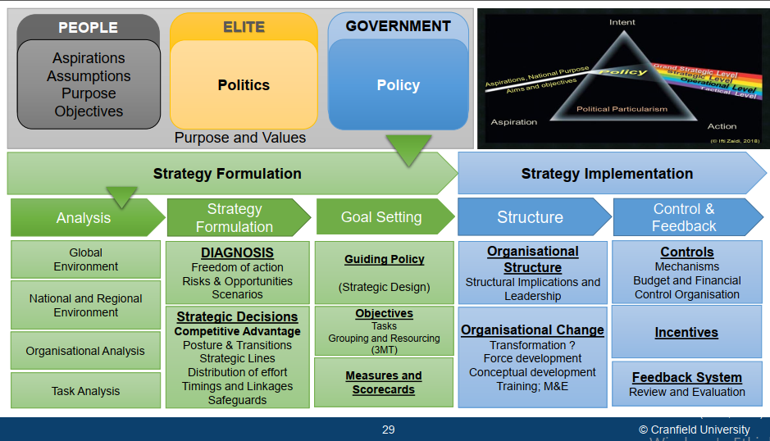

* + Below chart gives more strategic version of it.

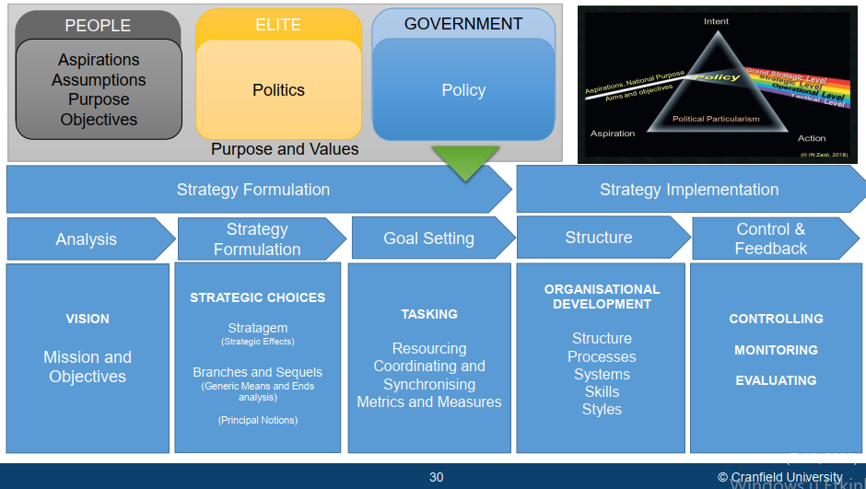

* + dd
* **Points to Ponder**
  + IZ argues that there is inherent tension in Policy and Strategy. Why is that? Below paradoxes make strategy very difficult.
    - Development Strategy is a Long-term undertaking …. Several decades in some cases. Like does Nigeria need an aircraft carrier? If so this takes 20 years. What happens in 5 year time to notice that there is no need? Billions of dolars are gone. UK pumped lots of money for 3 air craft carriers in 80s. In 90s it decided they do not need. 2.5 b /of 7-8 b £ spent. They scrapped the program. 2003 Blair said we do need aircraft carriers. Program becomes 20 b. Why Blair did that?
    - Policy typically manifests a gradualist paradigm, albeit with some level of stability between governments. May replaced by Jonhson. May experienced sort of punctuated equilibrium and Johnson came with completely different mindset although the part was the same. PE ended with series of changes. This is another paradox.
    - The is an inherent paradox in Strategy’s need for punctuated equilibrium and policy’s need to remain politically responsive. Strategy must serve to policy, both adopted by gradualist adaptations of policy and those punctuated. This impact strategy very large extent.
    - Elite politics and political tenures further amplify the paradox
  + What (should) drives strategy?
    - Threat: UK cold war threat based
    - Capability: 90s
    - Financial Capacity: we can only strategy that we can afford. If there is no existential threat, this is good.
  + What drives policy?
* **Principle Notions in Strategy**
  + **Strategy Cycle:**
    - Strategy process is part of strategy cycle. Strategy cycle is a constant set of questions. Once first 3 is done, bulk of the strategy process is finished. It is not linear process, done again and again with time considerations. It never ends.
      * **Current:** Where are we today?
      * **Ends**: Where do we want to go? This is related to timeframe.
      * **Mission**: What we must do iot achieve desired outcomes?
      * **Strategies (Choices):** What are options? This is where you start to think about how to defeat opposing active intelligent mindset. Pumping new resources or with intellect (by understanding the psche of oppostion and its history).
      * **Plans** (strategy in action)**:** How?
      * **Measures and targets:** How can we know we have arrived?
        + You measure & identify specific targets, milestones that your strategy must achieve. In measuring progress shouldn’t be objective oriented.
        + Strategy is measured in terms of preset effects that you must achieve not preset objectives. It doesn’t make sense to measure no longer relevant targets. Environment may changed, you may be successful as per your measurements, but you're actually running at a tangent in terms of what strategy ought to have delivered. Famous speech by Bush in 2003 on aircraft carrier: victory achieved. In reality US is still stuck in that same war. So it wasn't achieved.
        + ‘However beautiful the strategy, you should occasionally look at the results.’ Winston Churchill
      * **Results and outcomes:** Are we there yet?
    - **Gap between strategy and plans** there is a huge *process (*but it is an intellectual leap that occurs). Intellectual process of identifying exactly what you must do iot overcome opposition. That is strategic guideline, or rather design.

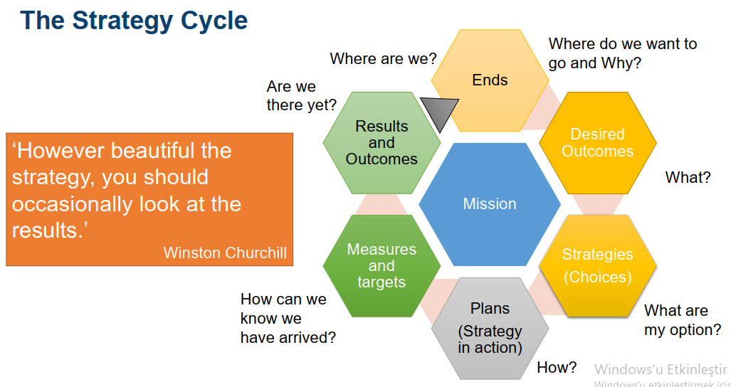

* + Simpler way of it and connects some of the tools we saw so far.
    - **Strategic environment:** IZ: It starts with knowing the world in relation to mission & objective. What are you trying to do and how environment effects this. Below tools are used with DELPHI method (it is an approach of logical problem solving). **Delphi:** one of idea-generation activity (brainstorming, brainwriting, delphi). The Delphi method offers more privacy still: Participants never meet face to face; instead they write down individually their proposed solutions for the problem as well as their rationales. The facilitator then sends these responses to all participants. Next, the participants revise their solutions, taking into account the views of their colleagues. The process continues iteratively until convergence or until there is no further progress (Chevallier, 2016, p. 128).
      * **PESTLE** Analysis : Analysis of the external influences on a firm: the acronym stands for political, economic, social, technological, legal, and environmental, i.e. issues that could significantly affect the strategic development of a firm. The former acronym, PEST, has been expanded to include the legal and environmental aspects (Law, 2016, p. 424)**.**
      * **Understanding scenarios**: What is this future world?
      * Then it comes mission and organizational development direction.
    - Then it comes organizational analysis in relation to the mission. Most used tool is **SWOT**
      * Internal: Strengths and weaknesses
      * external: what is happenning outside, in the market? Opportunities and threats.
    - Now you can generate strategic options.
      * Once you generate those options you need to have a risk assessment. What are the payoffs&gains? What are the costs of these gains and payoffs. With risk matrix you do it.
    - Aftered filtered from risk, these options become choices. We can do that, do that etc. Thats the cost of it, payoff it.
    - Then you start to make the choice. Critical decision is the path you take. Once you choose the path then you build a strategy to make that path successful. In that strategy, you try to understand opposition and try to defeat it.
    - From this strategy or fountain head, your plans emerge. And from plans, action will emerge.
    - Risk assessment is continous.
    - It is like RAM? No, iin RAM there is no word like strategy in its pure sense. It talks about grand plans. From choices you go to big plans.

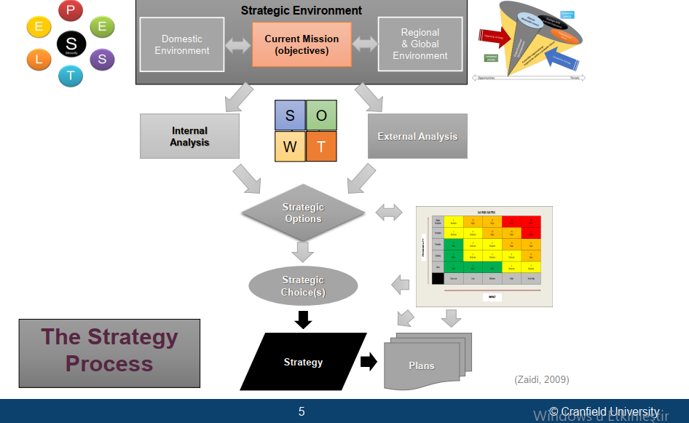

* **How Concept and doctrines relate to strategy**
  + Between aspiration and intent there is politics, so it cannot be purely rational. People in politics comes with interest with manifatetion of policy which moderates rationality (Political particularism). Every elected government brings its own prism (Conservative and Labour Party example). But the aspirations, aims and objectives of the people are constant. Each party arrive at a different set of policies draw different meaning from that same body of thoughts, ideas, aspirations.
  + This policy then moderate strategy, operations and tactics in many ways.
  + Going from intent to action: is in fact politically impacted. Actions must be tested against aspirations to move forward.
  + To put strategy into action a strategic intent is required. We have rules & regulations and processes in place. And we have got concepts and doctrines. These collectively helps to produce operations and plans. From these plans actions emerge. With these actions we reach aspirations. This is the cycle.
  + Dotted arrows are **feedback loops**.
    - **Strategic intent & concepts and doctrine**: To relate intent with concepts. What do we need to do? Is there something else that needs to be done and that's why concepts are so important? Because doctrines may not have always the answer. The concepts are things that are emerging, evolving, not linked as doctrines typically are. And then this whole idea of national purpose national aims and objectives and policies being also in a cycle.
    - **Policy and national purpose**: German people before WW2 and now. Did it all of a sudden become nazified? Suddenly decide to commit genocide?National purpose actually does not change. It may manifest some extreme characteristics for particular times. And those characteristics are usually products of either the events, or the personalitie.s In that case it was Hitler, and his team But eventualy it was stabilized back to normal form.
  + **Strategic atropy:** General Sounders&IZ: Strategy is being skipped and passing directly from choices to plans become normal. As a result we become so process oriented. And we forgotten what strategy is all about. This skip is the legacy of cold war. We stop thinking about active mindset, we started doing grand plans. Heyden: We became obsessed with the idea operational art and thought that simply successful operations would deliver strategic effects. But you’ve got to understand that linkage between operational level and strategic and policy. This is neglected. that simply capturing the hill would deliver the strategic. Whereas no you've just got a hill and that hasn't. Enable policy etcetera. IZ: If that hail is no longer relevant, the military commander might assume that he's captured the hill. He's done his job, but actually, no, you haven't done your job because that hill is no longer relevant. But when that hill was conceived as an objective, it was trying to serve an overall strategic effect. But if it’snt deliver that effect, that material objective has no value.

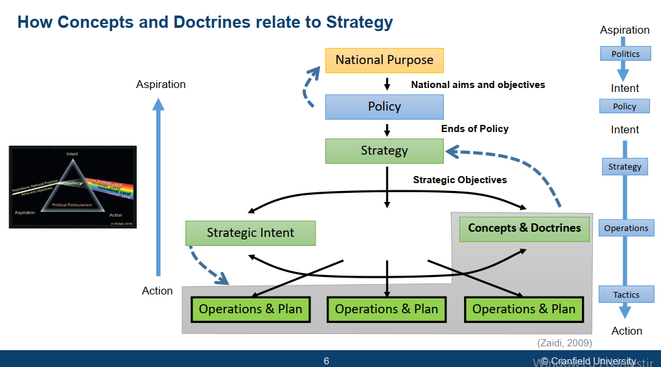

* **Strategic and Tactical (**main and auxiliary**) Effects:**
  + Strategy produces effects in order to serve policy. How?
  + Strategy in itself serves no purpose other than the effects that it creates. Colin Gray
  + Policy uses those effects to its political advantage.
  + So strategy isn't about achieving objectives or achieving tangible thing like territory, it's about creating an effect (psychological, moral, and physical). It's about what impact those spaces territories have on the overall political equation.
  + These effects are the nuts and bolts of the strategy.
  + “Strategy, like war broadly and warfare narrowly, has no intrinsic value. Strategy has worth only for its product, which is strategic effect” (Colin S Gray, The Strategy Bridge)
    - IZ: Strategy doesn’t produce objectives. To capture hill is not strategy. The question worth is to ask what the hill worth? What the capture of the hill does to the political direction you’re travelling.
  + two concepts of strategy which are fundemental in that dialectic of opposing mindsets.

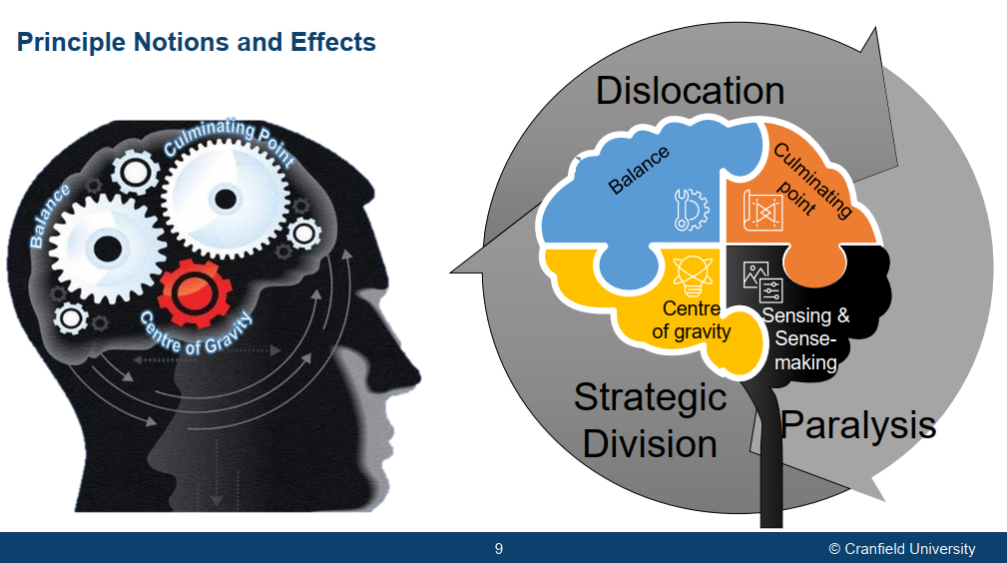

* + - **Principle notions of strategy**: **Balance, Culminating point, and center of gravity.** They are related to force. DIME and 3MT bit. Conceptual, intellectual and moral component of fightnig power (Combat or national power potential). Left of the picture. Balance is coming from classical thought, Jomini, and others. Other two, culminating point and centre of gravity is coming from Clausewitz. Sun Tzu, in fact talks about all three. He also talk about fourth one as the moral.
      * **Notion of balance:** IZ: Relationship between force A and B, their ability to mutually support one another is known as the notion of balance. It is actually not complete without having something in reserve (force C). So the moment B moves A to support it, leaving a small portion behind, C must move towards a little bit towards B to make sure that in case the main is still coming through B, C is available to reinforce B. It is like stool with three legs. A moment you drop a leg, you need to able to do something to make the stool balanced. At national level relationship or equation of balance is complicated, logistics, economics and so on. System of forces need to be a state of balance when each of its components are mutually reinforcing. In relation to time and space and relative strengths ratios required to overcome any opposition that comes on them.
        + On the nature of the war Clausewitz mentions about how military action may be suspended. While he responds that he argues the only reason might be the desire to wait for a better moment. He argues here that concept of balance. He argues that in a balanced situation the side with positive aim, the attacker always has the initiative to act. So balance can not bring the action to standstill (Clausewitz, 1989, p.82)
        + Importance of reserves to maintain the balance (Clausewitz, 1989, 231).
        + Shift in balance means gradual realities of a defeat observed by, melting away numbers, loss of ground, breaking up of original line, retreat and depend on the spriti of army the panic (Clausewitz, 1989, 254-5).
        + Clausewitz argues that, before battle there is real and assumed balance. And this balance is become upset by being defeated, and outside cause is needed to restore it.
      * **Culminating point:** Now as I move from here towards my objective. The moment I leave my base, I start using my resources. The closer I get to the objective the weaker I get. Enemy projects forces ahead to weaken me. Number of lines indicate its strength, its weakest in ahead most. The closer you come to the enemy, the stronger the enemy becomes and the weaker you become. A point is reached (between main line and ahead) where your strength in relation to that of the enemy is no different. In other words, Clausewitz argued that if you do not do something to delay your culminating point, you will reach a stalemate and will never be able to attain your objective. He argued first of all do something to weaken enemy. Before you get to CP you need to bring resources forward. You can rebuild your combat force and be strong again to move forward. If you can hasten enemy’s CP (attacking logistic lines, their will to fight) when delaying yours you are in advantegaous.
      * **Center of gravity:** CoG develops from dominant characteristics of the belligerents. These are the hub of all power and movement, on which everything depends. That is the point against which all our energies should be directed (Clausewitz, 1989, pp. 595–596).
    - **Principle effects of strategy:** 
      * Gray alludes but not extends what are these effects.
      * These are dislocation, paralysis, and strategic division, Coming from classical strategic thought.
      * Each of those these strategic effects is the product of the interplay of the three notions of strategy.
      * Each of these impacts the strategic effects. How these come together? There is physical side to all of these effects. You can achieve physical dislocation or paralysis etc. But there is also pyschological side, that’s why there is a mind in the picture. It is how our mind is interpreting those three notions. And what you really attacking is sense-making and sensing side of opposing mindset, while trying to strengthen your own sense-making.
      * Adeniyi: Iraqi forces are physically paralyzed in the short term but in the long term their mind was active and manifest this as insurgency. IZ: In addition to strategy cycle there is operational cycle. It draws work on Jomini, and it is deeply embedded into thinking Sun Tzu and shogi, classical confucian thinkers as well. What they argue is nobody can ever be on the defensive and nobody can ever be on the offensive. Implication of this: You have to make those transitions ~ One components of strategic decision: strategic posture and transition. Once you launched successful offensive like US did in Iraqi war, operational cycle has certain smaller components. The other side will go on defensive. Defensive has its own cycle. In this defensive cycle defense is only successful or defeated once the counter offensive has been dealt with. Now this is where the operational level strategy went wrong in Iraq. The counter offensive doesn’t really have to come in the same mode as the offensive. US offensive and initial Iraqi defensive were in the conventional mode. Having been conventionally defeated and the conventional capability denuded does not mean that you have won and that is where that psychological side comes in, that unless you have destroyed hope, the counteroffensive will come in some other ways and what happened was counter offensive came in the form of insurgency. And that is part of operational cycle. An insurgency,when you don't have conventional capability is a typical response to an operational cycle. And it's not new. It's not invented by Iraq or Taliban. Again strategic atropy, we ignore it, then we pay the price for that.
      * **Strategic effects:** Essentially two, that’s why strategic division is dimmed out. The first one is **paralysis** and the other one is **dislocation**. **Strategic division** becomes a main effect when a division of a body of collaborating forces is strategic in nature. For example, Britain and the US are in in an alliance, and the Russia do something to break this alliance. So strategic division can then become a strategic effect because it leaves each of those members isolated. Other than that, division of forces is in fact only a tactical effect.
        + **The concept of paralysis**: We apply force & do things with combat capability. So the concept of paralysis is to not need to fight this body that embodies that destructive power. Because if I try and deal with that destructive power, I'm going to get burnt. Overcoming bull which embodies a greater power than you can physically muster. If you were to try and overcome that bull by overcoming its power, you will get hurt. You neutralize that huge power that opposing mindset possesses through paralysis.

**Paralysis in the psychological sense**: Paralysis is exactly what the biological term implies. You paralyze the body, so the mind can see but unable to use its legs and feet. Paralysis can be achieved either through overloading, denying information or making events happen so quickly . While the bull sees there are something happening it's unable to react to any one of them because it is mentally confused and cannot pass those signals to the body to act.

**Paralysis in te physical sense:** Destroying an enemy's communication infrastructure. So you've got the command HQ, which makes decisions, but has no means of communicating these to forces for actions. In other words, that body that embodies the power and the mind that takes the decision for that body to act is intact, but the link is no longer there. And because that link is not there, that body cannot act and you are at liberty to then overcome that force.Decapitation for example, taking away a very important leader that is driving all the decisions would paralyze forces (Putin, Russian forces). There would be absence of next decisions.

**Body as an analogy**: It is literally separating the head from the limbs. The limbs are the one where power is manifest. The head is the one where the decision to apply that power is manifest.

* + - * + **Dislocation:**

Body as an analogy: If I was to dislocate one of your legs, you will limp and you will be less effective.. That limb is intact, it is not being destroyed. I've just dislocated it.

In the context of a force: It's about time and space. If a decision is being made in Central France and the BEF is sitting in Dunkirk, that is the notion of dislocation. That force is intact, and has full combat potential, but it's at the wrong place and any effort to now get to the right place will put it at a strategic disadvantage and would render it useless & open to destruction. And that is why the made no effort to try and come back to where the action was. The same happened to the French. They were dislocated. They were sitting in the center, but they were drawn to the South, Toulouse. Once they came to the South they were out of the the zone where decisions were being sought and Guderian Forces ran right the way through. There was also an element of paralysiS because the rate at which the Germans were advancing was faster than the rate at which the French high Command was able to take decisions.

* + - * + **Strategic divisions**: There is two people who collaborate and collectively make a formidable force. Drive a wedge between them and make them these two now no longer cooperating, and you are in a better position than you were before.
      * **Producing these effects through tactical (auxilary) effects:**
        + The main effects cannot be directly produced. In order to achieve these main effects, you have to create **tactical effects** which are achievable within the realm of tactical fighting units in the military, or embassies in diplomacy, or the media and the other means of information in the information sphere and through economic action like sanctions and so on in the economic sphere.
        + **Attrition effect**: In Ukraine war initially through sanctions s we are trying to cause attrition on Russia's economy. Bombarding cities (Mariupol and Harkiv) is attrition and this wears down its resistance.

Attrition requires use of your energy. You expand your force, which is not retrievable. Once an arrow is fired, that arrow is gone, you are one arrow less. So it is an expensive approach and doesn't always produce the right results.

Attrition is nonetheless a an auxiliary effect. Connection of this to create strategic effects (dislocation, paralysis or division) is an intellectual undertaking.

* + - * + **Compression effect:** Battle of Thermopolea. It was a several thousand strong Persian army against 300 Spartans. And history tells us that the Spartans won. And the reason for that was that the battle was fought on a narrow path. And on a narrow path it does not matter how big your army is, the combat power that you can generate is only what is possible on that narrow pass. The point to take away is that every weapon system or military unit, or marketing product has the notion of optimum space. How much space a tank needs to be able to generate full combat power. You compress that space and tank is the same, but it will not be able to generate the same amount of combat power. It's like trying to use a rifle in a fist fight. But a pistol is better because the rifle needs a little bit of space for it to operate optimally. A pistol needs smaller amount of space come even closer into a wrestling match. The pistol also becomes useless. Compression make your enemy constrained in a space where they are no longer able to generate the combat power. It will be immaterial how much strength they possess. So you have then neutralized their ability to generate full combat power.
        + **Containment effect:** It is all about a force being initially deployed, and preventing that force from changing that disposition. So you contain them in those spaces where they were initially fixed.

If, for example, an air force configured it's weapon systems in one particular way, you can then do something to make sure that multi role aircraft can't be reconfigured. Maybe play with their supply chain. If defensive forces deployed in an irrelevant defensive line and you do something to make sure that they are there remain there. It is connected with another notion of effect, which is fixation.

* + - * + **Destruction effect:** destroying
        + **Dilution effect:**  It is the opposite of compression. In order to generate proper combat power different components of a force need to be able to interact. Dilution is the preventing troop interaction which generates a combat power, through stretching them out in space. The best example of dilution is perhaps the Napoleons or German venture into Russia. The forces just simply dissipated and disappeared into the vastness of theRussian landmass and therefore could be easily picked up.
        + **Dislocation, fixation and containment:** Germans feigned at two places. One in accordance with the Schlieffen Plan (it was for the Germany come into France through the Low countries). The other one was at Maginot Line. Germans demonstrated presence of a large force accordingly. Result of these actions:

French defenses in the north became fixated in the north. French defence forces were contained.

BEF movement from center to the north into Dunkirk was dislocation.

The French reserves were at behind Ardennes were pulled to the south (Maginot Line faint). Dislocation.

* + - * + Once this disposition had been achieved, Germans went through the Ardennes in a rapid offensive and reached the end. None of these forces, which were intact, could react. That was how France was overcome in a matter of of days.
        + **Dilution:** In Operation Barbarossa, German forces were able to collaborate initially, but the further they went out, the more isolated. They weren't able to sustain them because quite simply the they were just diluting into the vastness of Russian landmass.
        + **Containment**:

German 7 th Army contained French forces behind Maginot Line to make sure that the French do not get out,

German 6th Army in the north made sure that the BEF do not retreat and interfere with the main operations.

Germans did not attack, it was just that their presence was enough to prevent any action on the part of this and that is what we mean by the notion the the effect containment.

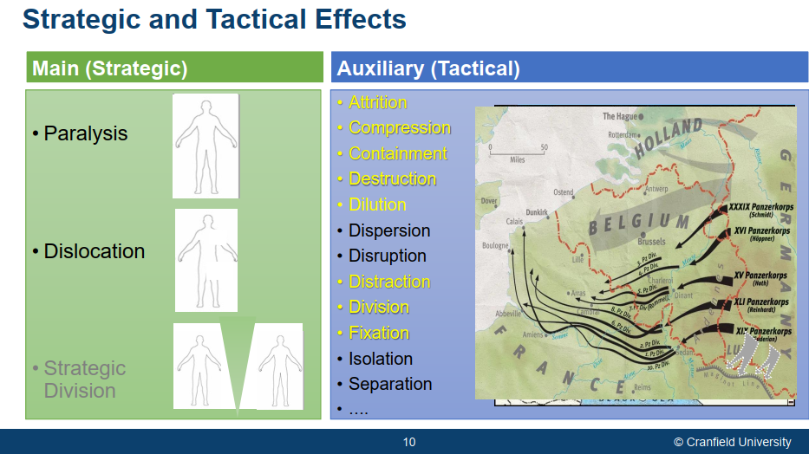

* + **Strategy bridge**
    - To produce successful strategic line (e.g. military success) we must produce tactical effects (e.g. military action). Tactical engagements need to be directed in the right place, military action is conducted in appropriate way.
    - Problem is just doing tactical actions does not automatically connect you with military success. We have to have strategic effects (dislocation, paralysis, strategic division) to produce that strategic success. You captured the hill but it became not relevant because it lost its strategic effect.
    - Now this notion gets replicated at the higher level in terms of ends of policy. What we would like to see is successful military operations. Contributing to the ends of policy, but successful military operations don't necessarily produce ends of policy. If you look at Vietnam War, Afghanistan, Iraq, there are hardly any tactical actions that the Allied forces suffered defeated. Probably none. But this connection was still not there. The ends of policy were not attained, and that is the absence of a strategic design that connect military outcomes into political effects, which can then be utilized by policy. That hill would be relevant if it produces political effect.
    - We ignore the middle stage.

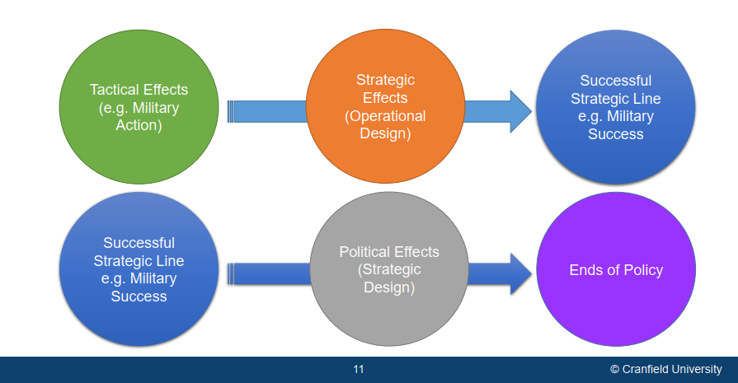

* **Strategic and Operational Design ~Expression of strategy:** I will then take something that we frequently ignore, what we do in the field and how that connects with policy and strategic and operational design become critical.
  + **Directive 21:** Strategic design of WW2 from German perspective. Is a very small document. But in that small document it contains all the wisdom for what the Germans were trying to do and how they were going to do it. Within that document, the essence of strategy was only about half a page equivalent, it was spread out in the document, but if you were to collate those components you would find that it was less than half a Page 3 paragraphs.
  + Within this diagram strategic design sits here. It's what makes sense of everything. It is central to your strategic intent and application of concepts and doctrine. It is what drives operations and plans through a lower design which you can refer to as operational design.
  + At the tactical level there is no need for a design because it is action, engagement. 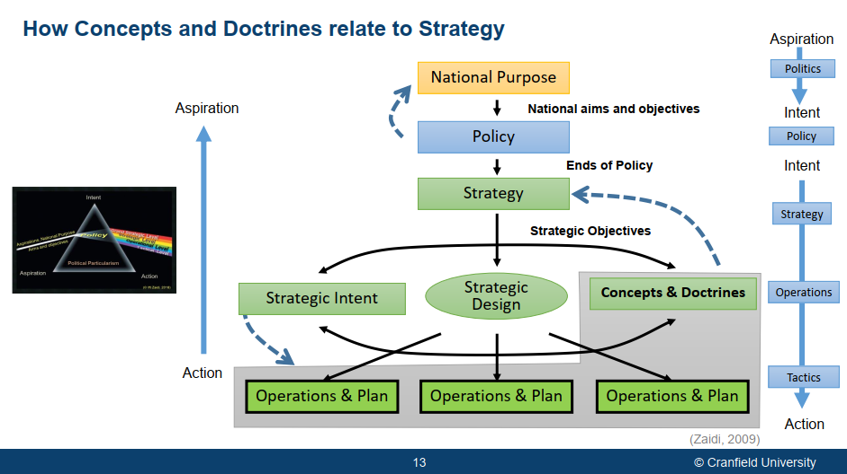
  + **What does the strategic design do?**
    - Serves as the **basis guideline for subordinate levels** of operation
      * IZ: It clarifies in the mind of the commander how the opposing mindset to be overcomed.
    - Identified opposing strengths and weaknesses and indicates **what strategic effects are to be created** **and accentuated** to exploit critical notions (Imbalance, CoG and Culminating Point) You are targeting these 3 things while protecting yours.
    - Clarifies the basic idea, **stratagem(s) and golden thread** linking strategic lines, operational lines and tactical manoeuvers.
      * How will you marginalize enemy strength with without physically confronted?
    - Conceptualises various **forms of manoeuvre** for subordinate levels to translate in to efforts or echelons.
    - Fixes **time and space linkages**, relationship with effects desired
    - Looks at the **whole operation/campaign** from beginning to end.
  + STRATEGIC DESIGN: BARBAROSSA, green -minor, tactical effects,
    - The German armed forces must be prepared, even before the conclusion of the war against Britain, to crush Soviet Russia in a rapid campaign. While ensuring strong defence in the West, keep the US out of the war in Europe and ***distract*** Great Britain in peripheral campaigns ***to create*** space for operations.
      * ***Distraction:*** political agreement with Russia was part of that, pullin UK to north africa. Forcing Churchill to pull US forces to there also. Germans had no interst in north africa. They know UK very sensitzed to Suez canal, any threat to cansl would pull disproportinate response from GB. Rummel was never there to produce main effect. He was producing auxilary effect of distraction.
    - The bulk of the Russian Army stationed in Western Russia will be ***isolated*** and ***divided*** by daring operation led by deeply penetrating armoured spearheads before being (encircled and) ***systematically destroyed***
      * Why isolate and divide not others? The reason is encapsulated in the term “systematically destroyed”. In the Battle of France, Germans only dislocated GB forces and not bother to go after the forces stranded in Dunkirk or the French forces stranded in the South. The Germans made no effort to destroy them. Right whereas with Russia they opted to systematically destroy them, because their objective ultimately was the complete domination and occupation of Russia. Or to be more precise, they were looking only at the Ukraine. That was their target. So isolation and division is preludes the destruction.
    - Russian forces still capable of giving battle will be ***contained*** and ***prevented from withdrawing*** into depths of Russia.
      * The same, isolate, divide and then destroy.
    - The enemy will then be energetically pursued and a line reached from where the Russian air force can no longer threaten German territory. The final objective of the operation is to erect a barrier against Asiatic Russia on the general line Volga-Archangel. The last surviving industrial area of Russia in the Urals can then, if necessary, be eliminated by the air force.
    - In the course of these operation the Russian Baltic fleet will be ***disrupted*** by ***denying*** them bases such that they are no longer capable of action while the Russian Air Force is to be ***paralysed*** by powerful blows at the outset so that it is no longer capable of effective operations.
    - On the flanks of our operations, we can count on the active support of Rumania and Finland in the war against Russia and on Italy to keep Britain ***distracted*** and ***divided,*** making her incapable of interference on our Western front. Distract Surprise Isolate Divide Contain Dislocate Destroy (Zaidi, 2015, extracted and adapted from OKH Directive 21- Barbarossa)

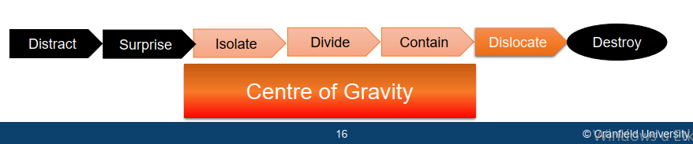

* This design started with distraction. Produce surprise. Isolate, divide, contain forces and ultimately led to dislocation. And it's it's impact on on Russian forces was ultimately destruction. It was about the center of gravity. That was the notion that was being followed so the whole objective of what the Germans were doing was to expose the center of gravity which they identified as Moscow.
* The whole idea of this design was pursuing a center of gravity approach to political advancement.
  + STRATEGIC DESIGN: France 1940, Critical Imbalance
    - The French perceive a major German offensive in the northern sector through the low countries. Allies strength lies in strong defensive positions supported by mobile balanced reserves. The northern and southern sectors are strongly defended but there **is a relative weakness in the centre**. The Strategic reserve are well positioned but their state of preparedness is inadequate.
      * Center is weak because the French perceived that there are no major operations capable possible through the Ardennes
    - The imbalance in the centre will be accentuated by depicting a powerful offensive through the low countries and in the south with a view ***to draw*** the strategic reserve; while forces on the Maginot line will be frontally ***fixed,*** forcing the enemy to remain **dispersed.** Air and para-troops will ***distract and delay*** enemy reactions. The main offensive will be through the Ardennes, comprising strong and balanced panzer forces, supported by air to reach the Atlantic coast in the area of Calais with max possible speed causing ***division*** of French and British forces. Having achieved ***dislocation***, the French system of forces will be automatically be exposed to ***destruction*** if needed.
    - An un intended consequence resulting from operational tempo was paralyses - Germans force were able to get inside Allied OODA loop. Even the best strategy requires a compliant enemy
    - So this particular design began with deception. Required fixation division containment. To produce dislocation and ultimately destruction if necessary, it was about creating critical imbalance to capture CoG which is in this case was Paris.



* + What would have been Apple’s design: Business case is put to design language
    - **The end state within the strategic concept:** The IT Industry perceives Apple in a survival crises due diversification and dilution. While continuing to reinforce this perception, undertake creative product development through innovative use of available technologies in line with consumer trends and demands. Continuing to develop our computer and software divisions and diversify into the mobile devices market, an emerging component of interconnectivity and portability. To achieve these ends we will:
      * **How active opposition will be tackled:** Distract our competitors by feigning consolidation and downsizing thus drawing them away from our intent (to create smart mobile devices market) and towards perceived opportunities of acquiring valuable components of Apple Corp.
      * **Then what?** Build a loyal customer base based around interoperability/connectivity among apple products, exploit past successes, optimally utilise available technologies and demonstrate an uncompromising drive for quality. Remain ahead of the competition through continuous product development and innovation, door-to-door support, and variants to appeal to a wider base.
      * **Use of other sources of power:** This will be supported at all stages by aggressive marketing based on customer experience, close cooperation with third party developers and suppliers, and strong market intelligence to inform Product design and software development.
    - Apple even to this day does not do any research and development or or. Basic product development of its own, it just puts things together. It buys things in the open market and puts them together. That has remained Apple's design, whereas Samsung builds its own screens and chips and so on. So if you look at this design, it's it. It's it starts with giving the end state. Then it talks about how the opposition will be overcome. It then looks at what happens next. It then talks about, uh, sustainability of their success. It starts with distraction. Use a surprise. Dislocation consolidation the moment you consolidate you have now transitioned from the offensive to the defensive, and then it goes into defensive maneuvers like this containment disruption and again consolidation. Whenever you consolidate, you give your opposition the opportunity to catch up, and that is why today Samsung is perhaps again a little bit ahead of Apple. Maybe not in market share, but in product quality and product versatility. This is about balance and culminating point maybe combination of two: Some designs may play with all three notions, some may only focus on one, it's it's for you to decide.



* + - Notion of victory:
      * In in in politics. Victory and defeat are not like a football game. It's not like who scored the most. If you look at the Arab Israel War 1973, militarily, the the the uh Egyptians lost. But the Egyptians had never planned for an operation beyond the measure of the the bar Lev line. The only thing they wanted to demonstrate was their ability to defeat the Barlev line, and their perception was that if that comfort zone which Israel sits in as a result of the bar Lev line, can be. Destroyed, uh, then, uh, potentially dialogue would open up, so while militarily. The Egyptians lost politically. They won because it led to the date and accord and allowed Egypt to again interact with the West and and and and so on. It opened up the doors for Egypt, which is what Anwar Sadat was hoping for.
      * Does victory need definition?
        + Similarly, in the Vietnam War, the Americans won every tactical victory, yet they had to exit ignominiously to from that theater, and Carl Schumer. This dialogue between kernel 2 and Carl Schumer. Do you know that you never defeat us on the battlefield and kernel? Two response. That may be so, but it's also irrelevant.
        + One of the most startling facts about the Vietnam War, one that has not received due attention among practitioners and scholarship, is the evident dissonance across different levels of strategy in the US as to what victory meant and what needed to be done to achieve it!!!
        + The North Vietnamese, in contrast, clearly understood its meaning, implications and what needed to be done to achieve it, from the strategic to the tactical level.
      * So what is it? Victory is socially constructed. It has a time value and it is expectational. What do I mean by socially constructed? It is in the mind of the beholder. Like Beauty, you can actually be defeated in another person perception, but in your own perception you may conceive that as something to celebrate. So there is a social constructive element to the victory. It often translates into hope. Defeat often translates into hope for the future, and that keeps the notion of victory alive. It has a time value. If you link victory, uh to political ends, then that victory should produce usable outcomes for those political effects. And if you cannot generate those political effects in that time frame, then you have lost the temporal dimension of victory. (Zaidi, 2011)

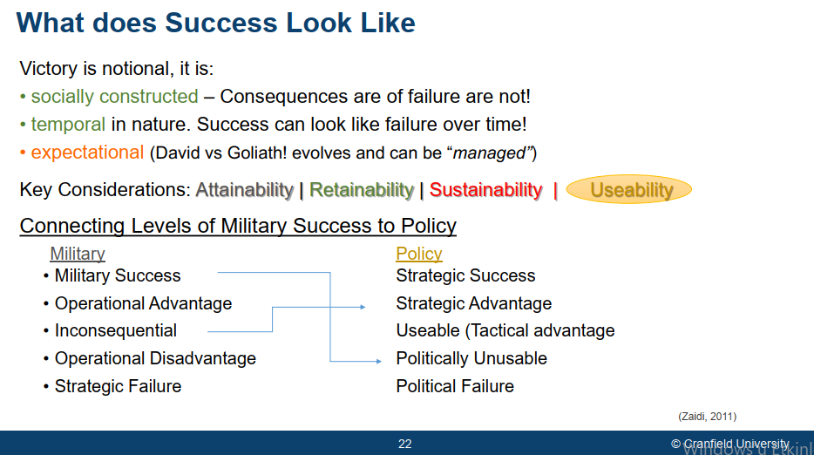

* + - * An example of this would be the British success in the Falkland War. In my view, that was one of the best examples of of purposeful war in the 20th century. To be honest, I don't think there have been any since either. Now if you look at the the the context. Britain was left alone. Article 5, uh? Revised, not include overseas territories.
    - It has a time value. It's expectational when Russia attacks Ukraine, you expect Russia to win. You expect it to be a swift operation. It's that David versus Goliath. Now, Ukraine has far from one, but the fact that it has caused casualties on Russia? Do we all not perceive Ukraine as winning? We do, don't we? Ukrainians themselves perceive themselves as winning whereas the reality is that the Russians are steady and still still sitting inside
    - Ukraine and in my own initial analysis, they're offensive or Kiev was a faint to keep the. We, to draw Ukrainian forces away from where the decision is being sought, and that decision is being sought in the South and the east. So the fact that the Russians are pulling out from near Kiev from my thinking perspective, uh, from my perspective I should say is not that they are losing. It's said that was never intended to be a main effort. It was never intended to be an objective. It was to design to to threaten things that are very close and very important to Ukraine, Kiev, Chernobyl, those that nuclear power plant. I believe the the two power plants there, uh, provide about 40% of electricity to Ukraine, so it was those things that they were targeting. But that wasn't the objective. The objective was creating that land access, which includes taking everything from Kharkiv along the Perovski River down to her son. That was my analysis in 2014, and I think a lot of that has been vindicated today. With what's going on? Whether the Russians achieve it or not is a different story.
    - So to summarize, if you achieve military success and it produces politically unusable outcomes, then that military success is money. Lives, effort lost. If you have an inconsequential military outcome, but it provides political advantage to policy, then I would refer to that as a strategically advantageous outcome, so Please remember that the object of military operations is to advance policy, not to win in its own right. Key consideration or can you attain your end state? Can you retain it long enough? The military and state that is, can you retain it long enough for it to? Be politically usable.
    - Can you sustain it over the period of time where that political utility of that end state is is made, and ultimately, what is the usability of that end state that is critical?
  + Not every, not even the best military strategy can guarantee victory, but an inappropriate one will all but ensure failure. (Echevarria, 2017)
  + **Strategy in VUCA world.**
    - Alfred Chandler’s “strategy drives structure”. “The **determination of the long-run goals** and objectives of an enterprise and the adoption of **courses of action** and the **allocation of resources** necessary for carrying out these goals.” Alfred D. Chandler
    - **Minzberg questions this. Emergent Strategy:** One of the challenges of strategy is trying to identify what exactly is going on – what is the strategy of an organisation. Every organisation will have a strategy, in the sense of a plan for achieving its goals, but this may not be articulated, or it may be commercially sensitive. Some organisations therefore position strategy as meaning goals (the **End**) whereas strategy is very much about the **Way** and the **Means**.
    - Henry Mintzberg identifies the metaphor of a **pattern** as a way of conceptualising strategy. A pattern in a stream of actions.

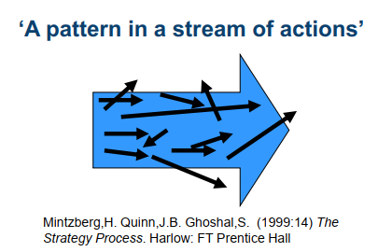

* + - * Without completely negating Alfred Alfred Chandler's thinking, he argued that strategy is a pattern in a stream of decisions. And he says that you will often have to do things reactively in order to impact a strategy over the long term. And he identifies it in this way.

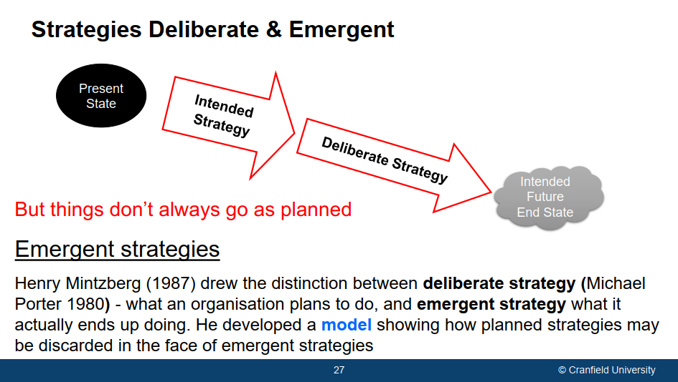

* + - * Present state. This is the deliberate and intended strategy that you produced and you try to put your deliberate strategy into action with a view to reach your intended future goal.
      * On that journey, what happens is that, things don't go as planned. And what actually happens is strategic shock. Green arrows could be COVID-19 hit. The resources that were planted here are no longer available. What you then have this is this gap. And in order to react to this gap, you then need to be able to do something you have to respond and in responding you have moved away from your deliberate strategy and what you've started to do is is what what mintzberg refers to as emergent strategy. So a series of emergent decisions change that strategy, and your realized strategy is nothing like your deliberate strategy. End state become unachievable. You achieve another thing. Bit like Lindblom idea of incrementalism.

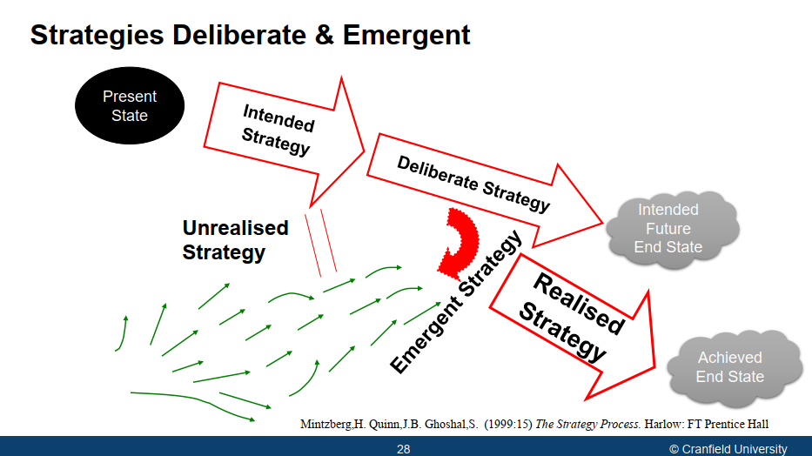

* Strategy lenses: Whittingham and Scholes four lenses:
  + **Design:** Strategy as design Views strategy formulation **as a rational, logical process**. Information is carefully considered and predictions made at the highest level. Strategic choices are made and implementation takes place. **Strategy comes from the top**
    - High legitimacy, low rationality and low innovation
  + **Experience:** Strategy as Experience: Views future strategy embedded in **experiences gained from past strategies**. There is strong influence from the received wisdom and culture within an organisation about how things should be done.
    - Strategy occurs at strategic management level. Heading func divisions. Things that worked in the past.
    - They lack innovation, it assumes history repeat itself.
  + **Ideas:** Strategy as Ideas: This is the view that innovation and new ideas are frequently not thought up by senior managers or leadership. Rather, new ideas will often be created throughout a diverse organisation, and even outside it as people try to carry out their everyday jobs and to cope with changing circumstances
  + **Discourse**
* Strategy is about using the right language. Words of CoG, balance, CP, main effects, strategic effects like dislocation, division, paralysis. This language makes sense now. It is the use of language to express strategy. It allows strategy to have greater meaning. Language become thought. And thought generates greater thought.

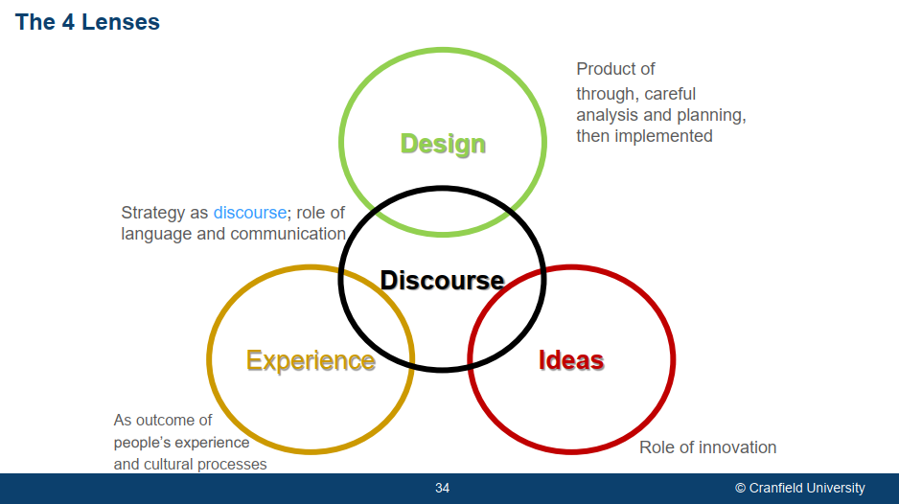

**Difference Between Strategy and Plan**

|  |  |
| --- | --- |
| **The Plan** | **The strategy** |
| A plan is usually **a list of steps** taken to accomplish a goal. A plan tackles questions like **how, when, where**  **and who**? A plan is a good thing to have. In fact, it is vital to the success of almost any effort. However developing a plan should not be the first step in  addressing a task.  • A plan focuses on **questions demanding detail**. It tells  us: ***“here are the steps”***  • The Take Away: Remember, having a plan is essential, but developing  a strategy should always come first. | A strategy is bigger than a plan. Strategy  tackles the question of **what and why**? It has a large scope (in ambition, resources and time).  Focus is on the end **resul**t and **consequences**.  • A strategy examines all influencing factor—seen and unforeseen. It comes to terms with the whole situation, not just end result.  • Strategy **reasons why and what**, it tells us: ***“here is the big picture”*** |
| Strategy is the overarching wisdom that coordinates many individual plans. The plans collectively achieve the ‘ends’ envisaged by strategy. Strategy coordinates and shapes the details in plans. | |
| Don’t try to fit a strategy around existing plans. Develop the right strategy <> Structure relationship and create the appropriate plans from strategy to use structures, systems & processes | |
|  |  |
|  |  |

* **Levels of strategy, (Zaidi, 2015)**

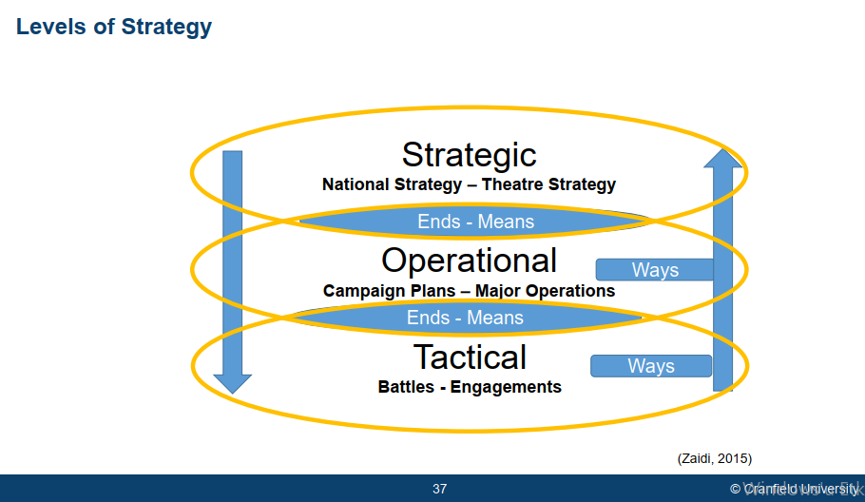

* + - Strategy travels from top-down with giving objectives and resources to down with leaving them to decide ways.
    - Effects travels down to top.
  + Linkage between strategy and plannig

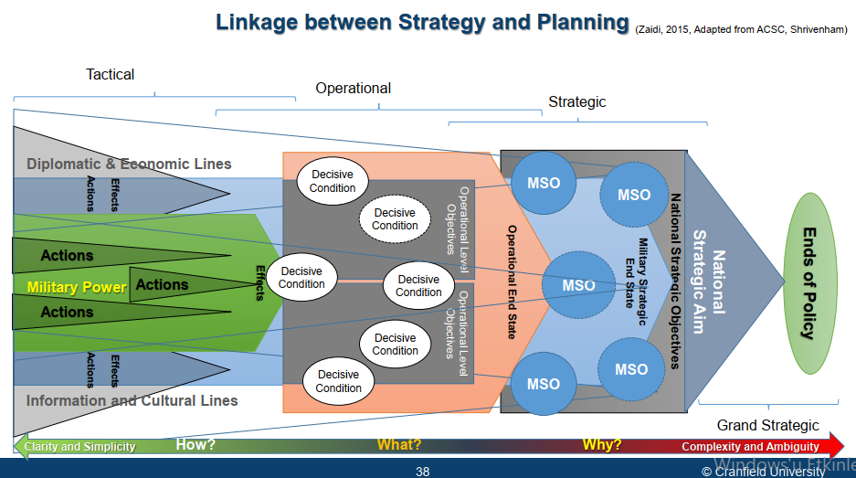

* + - * Translate into national strategic aims. Uh national strategic objectives. Each of these strategic objectives is attained through lines of operation, whether they're diplomatic, military or economic, and in each of these lines there are effects created through actions. For example, opening an embassy, signing a trade accord, or Opening a military base, deploying something a new piece of kit somewhere. These are all those actions which create effects along each of these lines of operations that I've shown. Let's look at the military line of operation the military produces. Free strategic objectives. In order to achieve national strategic objectives, it may have several strategic objectives in collaboration with other components of national power. Each of these components needs to be achieved through what the military has. It is forces, so the operational level is given certain operational end states to achieve which produce these militaries strategic objectives. Those operational level objectives are attained through decisive conditions to be achieved through tactical actions. Producing effects and, uh, that is how, the this this sort of golden thread uns from uh policy all the way down to actions at the bottom. So tactical, operational, strategic and grand strategic. The thing to note is that as we move towards the right. You have greater complexity and ambiguity as you move towards the left, there is greater clarity and simplicity and the questions alter. When you are in this space, the question is why are you doing something? Why am I capturing the hill? And you might realize that the hill is not important. Something else needs to be done. Then that why it translates into what at the operational level, and that might be the hill or the river. And at the operational level, thinking translates into tactical actions, which is concerned with how am I going to do that.
    - 2 strands of strategic thought
      * applied strategy, development strategy,

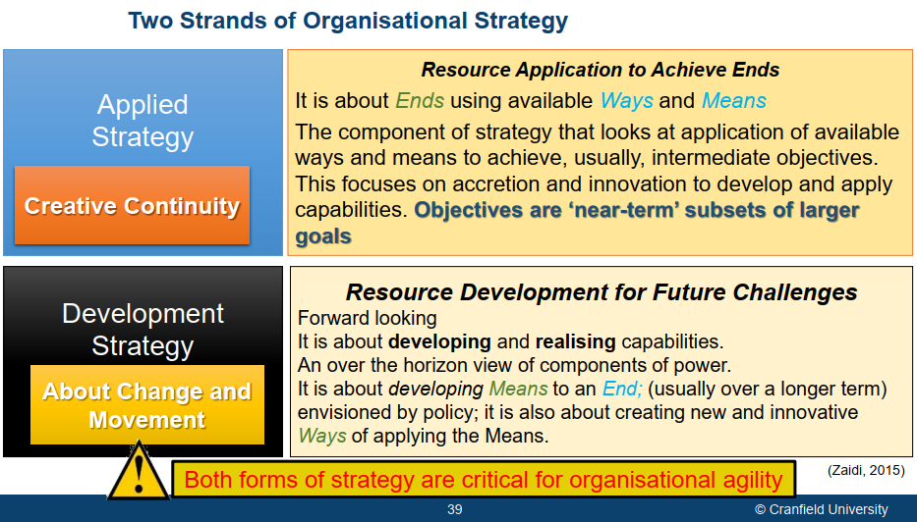

* **d**
* **Points to Ponder**

Bibliography

Chandler, Alfred D. Strategy and Structure, MIT Press, 1962.

Royal College of Defence Studies, Getting Strategy Right (Enough), 2017

Yarger, H.R. (2006) Strategy Theory for the 21st Century: The Little Book on Big Strategy, US Government.

Tzu, S. The Art of War, Oxford University Press, 1973.

Clausewitz, C.W., On War, Princeton University Press, 1984.

Hart L.B. Strategy: The Indirect Approach, London: Penguin, 1968

Lykke, A.F. (1989) Defining Military Strategy. Military Review, 69, 2-8.

Directive 21 German War pLan for Operation Barbarossa.

Zaidi, 2011, What success look like?

**(Zaidi, 2015) Levels of strategy**

Echevarria, A.J. (2017) Military Strategy: A Very Short Introduction. New York: Oxford University Press

Mintzberg,H. Quinn,J.B. Ghoshal,S. (1999:15) The Strategy Process. Harlow: FT Prentice Hall

Michael Porter 1980, Deliberate strategy

DIME, Joint Doctrine 1-18, Strategy, p. vii-viii

The Instruments of National Power The ‘DIME’ acronym (diplomatic, informational, military, and economic) has been used for many years to describe the instruments of national power. Despite how long the DIME has been used for describing the instruments of national power, US policy makers and strategists have long understood that there are many more instruments involved in national security policy development and implementation. New acronyms such as MIDFIELD (military, informational, diplomatic, financial, intelligence, economic, law, and development) convey a much broader array of options for the strategic and policymaker to use.

FPDM: foreign policy decision making

1. Perspective defined as a power, an outward directed vector.